**Must read topics in Deep Learning**

1. Overview of Different Types of Transfer Functions in Neural Networks

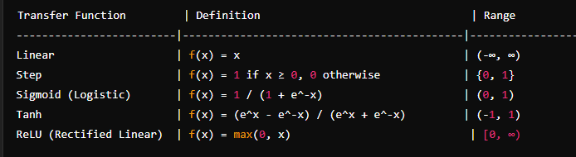

1. Basic Concept of Linear Separability in Classification Problems

**What is Linear Separability?**

* Linear separability means you can draw a straight line (or plane in higher dimensions) to neatly separate different groups of data points. It's like drawing a line on a scatter plot that cleanly splits two sets of points into their respective categories.

**Why is it Important?**

* **Easy Classification**: Linear separability makes classifying data easier because simple lines or planes can be used as decision boundaries.
* **Clear Interpretation**: The lines separating data are easy to understand, helping us see how the model makes its decisions.
* **Good Performance**: Linear models often work well when data is linearly separable and can generalize to new data effectively.

**Challenges and Solutions:**

* **Non-Linear Data**: Real-world data is often not linearly separable. We can use tricks like transforming data or using more complex models to handle this.
* **Imbalanced Data**: When one category has many more samples than the others, it can bias the model. Techniques like adjusting class weights can help.

**What to Remember:**

* Linear separability simplifies classification by allowing clear decision boundaries.
* For non-linear data, we can use techniques like feature transformations or more complex models.
* Understanding linear separability helps choose the right approach for building accurate classifiers.

1. Tabulation of Different Types of Activation Functions in Neural Networks

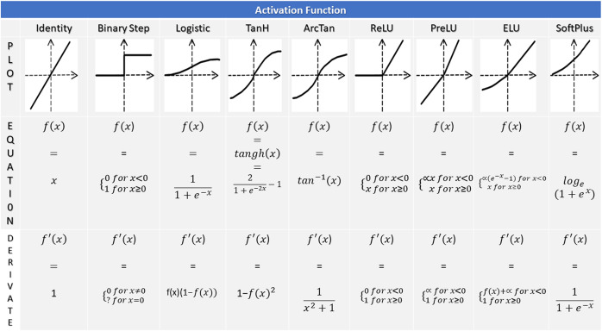

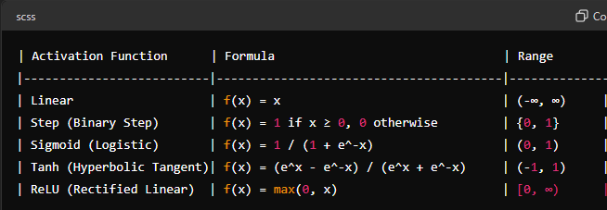

column continues

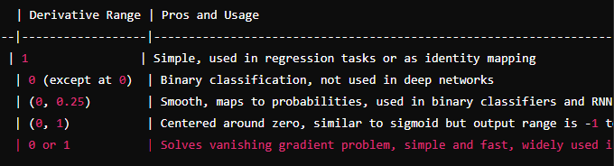

1. Importance of Data Normalization in Machine Learning

the importance of data normalization in machine learning:

1. **Faster Training**: Normalized data helps algorithms learn faster and more steadily during training.
2. **Prevents Bias**: It ensures that all features contribute equally to the model, regardless of their scale or units.
3. **Improved Accuracy**: Normalization can boost the accuracy of machine learning models, making them better at predicting outcomes.
4. **Less Overfitting**: By reducing noise and inconsistencies in the data, normalization helps models generalize better to new, unseen data.
5. **Easier Interpretation**: Normalized data is easier to understand and compare, making it simpler to draw conclusions and make decisions.
6. **Works with Various Algorithms**: It's not specific to one type of algorithm—normalization benefits many different machine learning techniques.
7. Definition and Significance of Thresholding in Image Processing

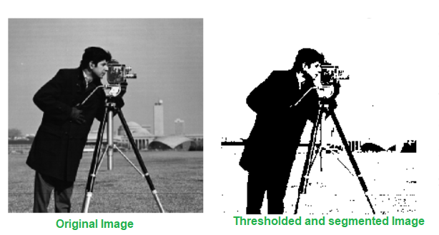

the important points about thresholding in image processing, simplified for easy understanding:

1. **Definition**: Thresholding is a method in image processing that converts a grayscale or color image into a binary image, where pixels are classified as either black or white based on a specified threshold value.
2. **Significance**:
   * **Segmentation**: Helps separate objects or regions of interest from the background in an image.
   * **Noise Reduction**: Reduces noise and enhances important features by isolating them from irrelevant background information.
   * **Object Detection**: Used for identifying and isolating specific objects or patterns in an image.
   * **Feature Extraction**: Simplifies image analysis by focusing on important features and ignoring less significant details.
   * **Visualization**: Binary images resulting from thresholding are easier to visualize and interpret compared to complex grayscale or color images.

In essence, thresholding is a critical technique that simplifies image analysis, aids in object detection and segmentation, reduces noise, and facilitates feature extraction, making images easier to interpret and analyze.

1. Understanding the Importance of Hyperparameters in Model Training

Hyperparameters are like settings or configurations that we choose before training a machine learning model. Here's a simplified explanation of their importance:

1. **Definition**: Hyperparameters are values we set before training a machine learning model. They control how the model learns and makes predictions.
2. **Importance**:
   * **Model Behavior**: Hyperparameters determine how the model behaves during training. For example, they can affect how quickly or accurately the model learns.
   * **Performance Optimization**: Choosing the right hyperparameters can significantly improve the model's performance. It's like tuning a guitar to get the best sound.
   * **Preventing Overfitting**: Hyperparameters help prevent the model from memorizing the training data too much (overfitting) or not learning enough (underfitting).
   * **Generalization**: Well-chosen hyperparameters help the model generalize well to new, unseen data, making its predictions more reliable.
   * **Model Complexity**: Hyperparameters control the complexity of the model. They can determine how many layers a neural network has or how deep a decision tree grows.
3. Comparison between Overfitting and Underfitting in Machine Learning

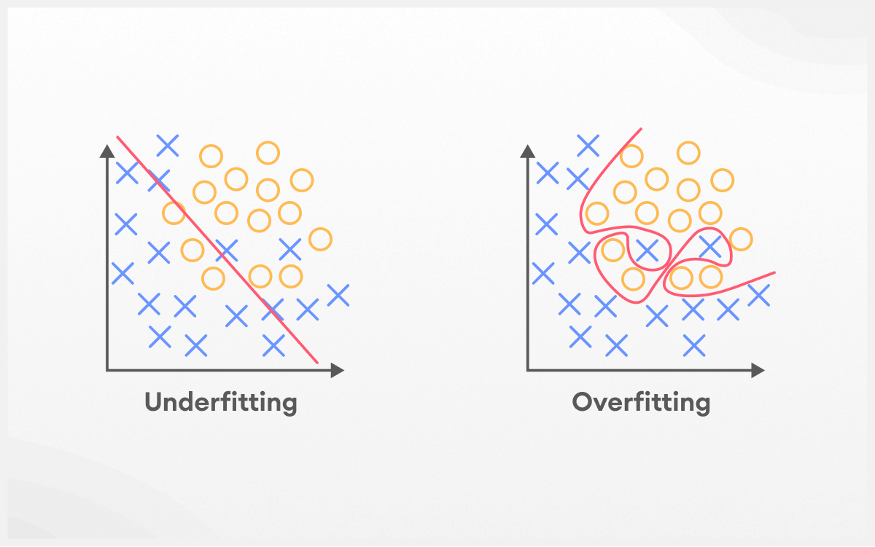

comparison between overfitting and underfitting in machine learning:

1. **Overfitting**:
   * **Definition**: Overfitting occurs when a machine learning model learns the training data too well, capturing noise and irrelevant details that don't generalize to new data.
   * **Effects**:
     + Fits training data perfectly but performs poorly on new, unseen data.
     + Model memorizes training examples instead of learning patterns.
     + High complexity or too many features can lead to overfitting.
   * **Solution**:
     + Reduce model complexity by using fewer features or regularization techniques.
     + Increase training data to help the model generalize better.
2. **Underfitting**:
   * **Definition**: Underfitting happens when a model is too simple to capture the underlying patterns in the data, resulting in poor performance even on the training set.
   * **Effects**:
     + Fails to capture important patterns and relationships in the data.
     + Performs poorly on both training and new data.
     + Can occur due to a model being too simple or not trained enough.
   * **Solution**:
     + Increase model complexity by adding more features or using a more sophisticated algorithm.
     + Train the model for longer or with more data to improve performance.
3. Brief Explanation of Gradient Descent Algorithm

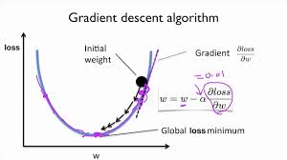

gradient descent algorithm in a simplified and easy-to-understand format:

1. **Objective**:
   * Gradient descent is used to minimize the error or cost in machine learning models during training.
2. **Process**:
   * Start with initial parameters.
   * Calculate the gradient (slope) of the cost function.
   * Update parameters in the direction that reduces the cost.
   * Repeat until convergence or a maximum number of iterations.
3. **Types**:
   * Batch Gradient Descent: Uses all training data at each step.
   * Stochastic Gradient Descent (SGD): Uses one random data point at a time.
   * Mini-Batch Gradient Descent: Uses small batches of data for updates.
4. **Learning Rate**:
   * Determines the step size during parameter updates.
   * Influences convergence speed and stability.
   * Choosing a suitable learning rate is crucial for effective training.
5. **Convergence**:
   * Gradient descent continues updating parameters until the cost function reaches a minimum or stabilizes.

In essence, gradient descent is an optimization technique that adjusts model parameters to minimize errors, with variations like batch, stochastic, and mini-batch gradient descent, and the learning rate plays a key role in its success.

1. Basic Concept of Backpropagation Algorithm in Neural Networks

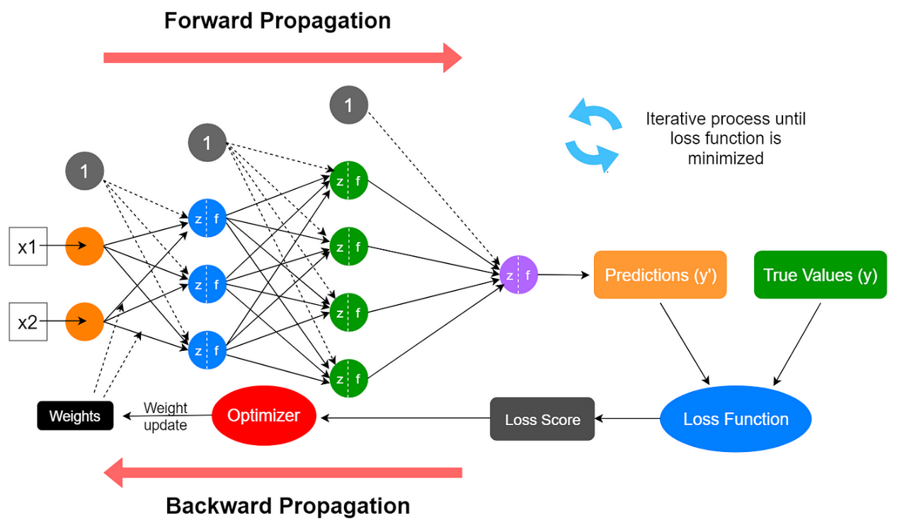

the backpropagation algorithm in neural networks with important points:

1. **Objective**:
   * Backpropagation is a method used to train neural networks by updating the weights and biases to minimize the error between predicted and actual outputs.
2. **Forward Pass**:
   * Input data is passed forward through the network, computing outputs using current weights and biases.
3. **Calculate Error**:
   * Compare predicted outputs with actual targets to calculate the error using a loss function like mean squared error.
4. **Backward Pass (Backpropagation)**:
   * Errors are propagated backward from the output layer to the input layer to adjust weights and biases.
   * Gradient descent is often used to update parameters, moving in the opposite direction of the gradient to minimize error.
5. **Key Points**:
   * **Chain Rule**: Backpropagation relies on the chain rule from calculus to compute gradients efficiently layer by layer.
   * **Gradient Descent**: Updates are made iteratively, adjusting weights and biases to reduce error.
   * **Activation Functions**: Derivatives of activation functions are used in backpropagation to compute gradients.
   * **Training Epochs**: The process is repeated for multiple epochs (iterations) until the network converges to a satisfactory level of performance.
6. **Importance**:
   * Backpropagation is crucial for training deep neural networks, allowing them to learn complex patterns and make accurate predictions.
   * It automates the process of adjusting parameters based on error, making neural networks capable of learning from data.

In summary, backpropagation is a fundamental algorithm in training neural networks, involving forward and backward passes to adjust weights and biases based on errors, allowing networks to learn and improve over time.

1. Difference Between Feedforward and Recurrent Neural Networks

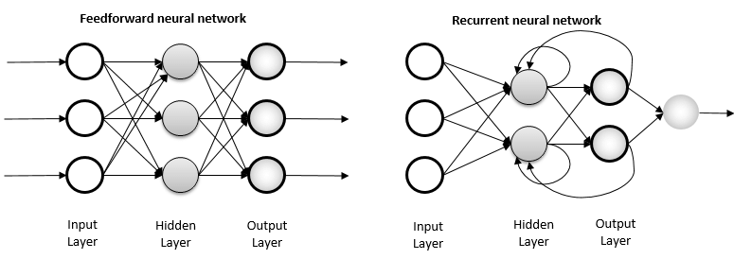

the comparison between feedforward and recurrent neural networks presented in a tabular format:

| **Aspect** | **Feedforward Neural Network (FNN)** | **Recurrent Neural Network (RNN)** |
| --- | --- | --- |
| **Data Flow** | One-directional (forward only) | Bi-directional (forward and feedback loop) |
| **Memory** | No memory of past inputs/outputs | Has memory due to feedback loop, can remember past inputs/outputs |
| **Architecture** | Simple layered structure | Looped structure with feedback connections |
| **Training Difficulty** | Easier to train | More challenging due to issues like vanishing/exploding gradients |
| **Use Cases** | Suitable for static inputs, independent data points | Ideal for sequential data, time series, natural language processing |
| **Examples** | Image classification, regression | Time series prediction, language modeling, speech recognition |

1. Process Cycle of Machine Learning

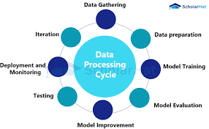

1. Applications of Speech Recognition in Machine Learning



applications of speech recognition in machine learning presented in easy and short points:

1. **Virtual Assistants**:
   * Powering voice-controlled virtual assistants like Siri, Google Assistant, and Alexa for tasks like setting reminders, sending messages, and searching the web.
2. **Transcription Services**:
   * Converting spoken language into text for transcription services, making it easier to document meetings, lectures, and interviews.
3. **Accessibility Tools**:
   * Enabling accessibility tools for individuals with disabilities by converting spoken words into text or controlling devices through voice commands.
4. **Voice Search**:
   * Facilitating voice-based search functionalities in search engines, e-commerce platforms, and navigation apps for faster and hands-free interactions.
5. **Interactive Voice Response (IVR)**:
   * Enhancing customer service through automated voice response systems for tasks like call routing, inquiries, and transactions.
6. **Voice-Controlled Devices**:
   * Enabling voice control in smart devices such as smart TVs, home automation systems, and automotive interfaces for seamless user interactions.
7. **Dictation Software**:
   * Supporting dictation software for professionals like doctors, lawyers, and writers to transcribe spoken words into text documents accurately.
8. **Language Translation**:
   * Assisting in real-time language translation applications, allowing users to communicate in multiple languages through spoken words.
9. Distinction Between Learning and Training in Machine Learning

distinction between learning and training in machine learning:

1. **Learning**:
   * **Definition**: Learning in machine learning refers to the model's ability to improve its performance over time based on experience or data.
   * **Process**: Learning involves the model adjusting its internal parameters (weights and biases) to minimize errors and make accurate predictions.
   * **Goal**: The goal of learning is for the model to generalize well to new, unseen data and improve its performance metrics.
2. **Training**:
   * **Definition**: Training in machine learning is the process of teaching or fitting a model on a labeled dataset to learn patterns and relationships within the data.
   * **Process**: Training involves feeding the model with input-output pairs and updating its parameters iteratively using optimization techniques like gradient descent.
   * **Goal**: The goal of training is to optimize the model's parameters to minimize the loss function and improve its ability to make accurate predictions.

**Key Differences**:

* Learning is a broader concept that encompasses the model's overall improvement and adaptation, while training is a specific phase where the model is taught on a dataset.
* Learning involves the model's capability to generalize and improve its performance beyond the training data, while training focuses on optimizing the model's parameters for a specific task or dataset.
* Learning occurs continuously as the model encounters new data or experiences, while training is a one-time process or iterative process during model development.

In summary, learning refers to the model's ability to improve and generalize based on experience, while training is the specific process of teaching the model on a dataset to learn patterns and relationships. Learning is ongoing and encompasses various stages, including training, validation, and adaptation to new data.

1. Elaboration of Forward Propagation in Artificial Neural Networks

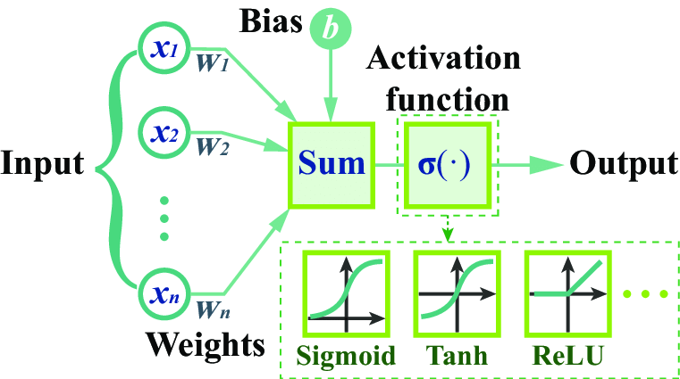

Forward propagation in artificial neural networks is the process of moving input data through the network to generate predictions or outputs. Here's an easy and short elaboration:

1. **Input Layer**:
   * The input layer receives the initial data, which could be features of an image, text, or numerical values.
2. **Weights and Biases**:
   * Each connection between neurons in adjacent layers has associated weights and biases. These parameters determine how input data is transformed as it passes through the network.
3. **Activation Function**:
   * Each neuron in hidden layers applies an activation function to the weighted sum of inputs plus bias. This introduces non-linearity and allows the network to model complex relationships in the data.
4. **Output Layer**:
   * The final layer (output layer) produces predictions or outputs based on the activations from the previous layer. The type of problem (classification, regression, etc.) determines the activation function used in the output layer.
5. **Process**:
   * Input data is multiplied by weights, added with biases, and passed through activation functions in hidden layers.
   * Each layer's output becomes the input for the next layer until the final layer produces the network's prediction.
6. **Prediction**:
   * The prediction is the result of the forward propagation process, where the network transforms input data into meaningful outputs based on learned parameters.
7. Relationship Between Cost Function and Gradient Descent in Neural Networks

The relationship between the cost function and gradient descent in neural networks is crucial for optimizing the model's performance. Here's a simplified explanation of their relationship:

1. **Cost Function**:
   * The cost function measures how well the neural network's predictions match the actual target values in the training data.
   * It quantifies the difference between predicted outputs and actual outputs, providing a measure of the model's performance.
2. **Gradient Descent**:
   * Gradient descent is an optimization algorithm used to minimize the cost function by adjusting the model's parameters (weights and biases).
3. **Relationship**:
   * During training, the model's initial parameters are randomly set.
   * The cost function calculates the error between predicted outputs and actual targets.
   * Gradient descent calculates the gradient of the cost function with respect to each parameter, indicating the direction and magnitude of change required to reduce the error.
4. **Optimization**:
   * Gradient descent updates the model's parameters iteratively, moving them in the opposite direction of the gradient to minimize the cost function.
   * By repeatedly applying gradient descent, the model gradually converges to optimal parameter values that minimize the cost, leading to improved predictions.

In summary, the cost function evaluates the model's performance, while gradient descent adjusts the model's parameters to minimize the cost function, improving the model's accuracy and effectiveness in making predictions.

• **Cost Function**:

* The cost function (cost_function) calculates the Mean Squared Error (MSE) between the predicted values of the model and the actual values in the dataset.

• **Gradient Descent**:

* gradient_descent performs gradient descent to optimize the model parameters (theta) by updating them iteratively based on the gradient of the cost function.
* The optimization process aims to minimize the cost function, indicating a better fit of the model to the data.

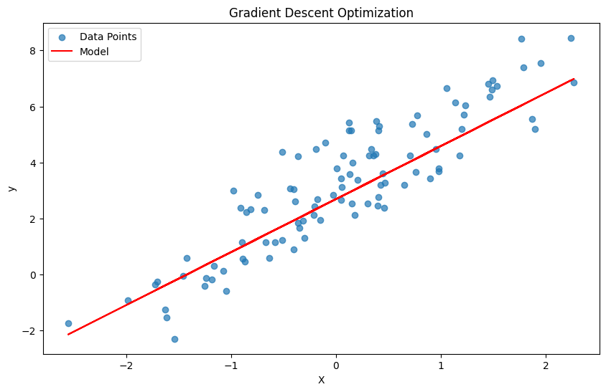 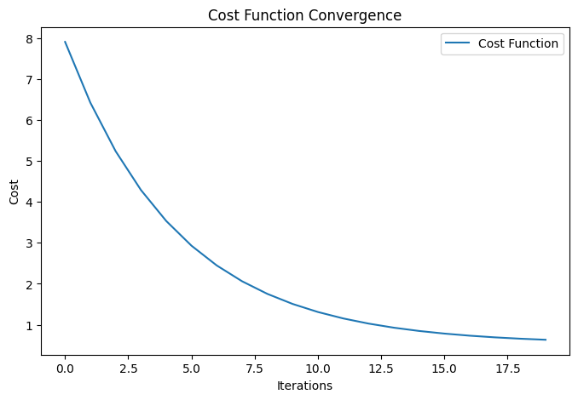

1. Challenge Associated with Artificial Neural Networks (with Diagram)

One of the significant challenges associated with artificial neural networks is the problem of vanishing gradients or exploding gradients during training. Here's an explanation with a diagram to illustrate this challenge:

**Challenge: Vanishing/Exploding Gradients**

**Explanation:**

* During the training of deep neural networks (DNNs) with many layers, the gradients calculated during backpropagation can diminish (vanishing gradients) or grow exponentially (exploding gradients) as they propagate backward through the layers.
* Vanishing gradients occur when gradients become very small, leading to slow or stalled learning, where earlier layers learn very slowly.
* Exploding gradients occur when gradients become very large, causing unstable training and making it difficult to find optimal model parameters.

**Diagram:**

css

Copy code

Input Layer Hidden Layers Output Layer

| | |

| | |

| | |

Gradients Gradients Gradients

↓ ↓ ↓

Vanishing Optimal Exploding

Gradients Gradients Gradients

In the diagram:

* Gradients from the output layer are backpropagated through the hidden layers to update weights and biases.
* Vanishing gradients are represented by very small gradients, causing slow learning and less effective updates in early layers.
* Optimal gradients indicate a desirable situation where gradients are neither too small nor too large, leading to effective learning and stable training.
* Exploding gradients are represented by very large gradients, causing unstable training and difficulties in finding optimal model parameters.

**Impact:**

* Vanishing gradients can result in poor performance, especially in deep networks, as earlier layers fail to learn meaningful representations.
* Exploding gradients can lead to unstable training, where the model oscillates between extremely large and small parameter values, making convergence challenging.

**Mitigation Strategies:**

* Use of activation functions like ReLU (Rectified Linear Unit) to mitigate vanishing gradients.
* Gradient clipping techniques to prevent exploding gradients by limiting the magnitude of gradients during training.
* Initialization techniques like Xavier or He initialization to set initial weights appropriately.
* Batch normalization to stabilize and normalize inputs to each layer during training, reducing the likelihood of vanishing/exploding gradients.

1. Significance of Perceptron in Perceptron Model

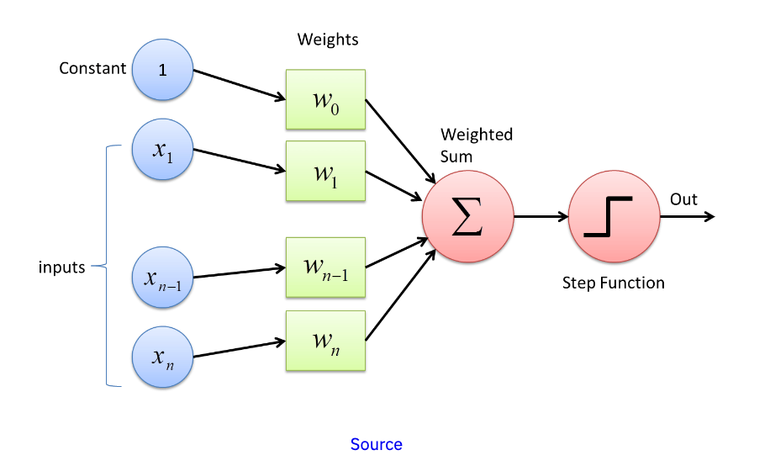

he significance of the perceptron in the perceptron model:

* **Binary Classification:** The perceptron is crucial for binary classification tasks, making decisions about whether an input belongs to one class or another based on a linear decision boundary.
* **Linear Decision Boundary:** It learns a linear decision boundary, defined by its weights and bias, separating input space into positive and negative class regions.
* **Activation Function:** Utilizes a step function or similar thresholding function for binary decisions, based on whether the weighted sum of inputs exceeds a threshold.
* **Training Algorithm:** Uses the perceptron learning rule to adjust weights and bias iteratively, minimizing classification errors during training.
* **Single Layer Network:** Represents a single-layer neural network, processing inputs linearly and applying an activation function for output.
* **Historical Significance:** One of the earliest neural network architectures, contributing to the foundation of AI and machine learning.
* **Perceptron Convergence Theorem:** Guarantees convergence and solution finding for linearly separable data, underpinning its utility in such classification tasks.
* **Limitations and Extensions:** While effective for linearly separable data, limitations exist for non-linearly separable data, leading to the development of more complex neural network architectures like multi-layer perceptrons (MLPs).

In essence, the perceptron is a fundamental element in the perceptron model, playing a key role in binary classification tasks with linearly separable data and contributing significantly to the evolution of neural networks and machine learning.

1. Utilization of Linear and Non-linear Activation Functions in Neural Networks

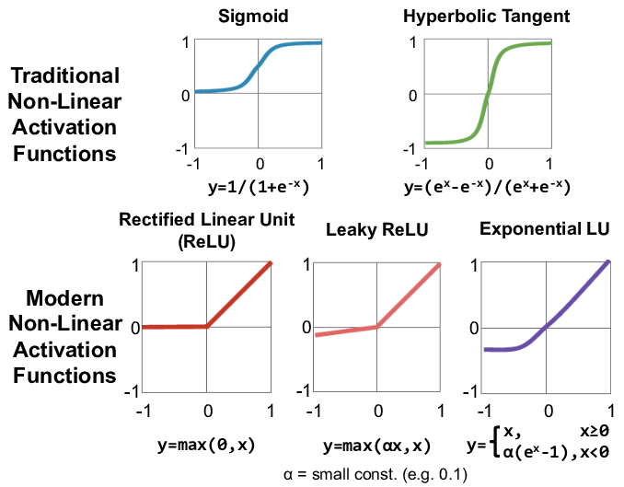

The utilization of linear and non-linear activation functions in neural networks is crucial for learning complex relationships in data and enabling the network to model non-linear patterns effectively. Here are the key points regarding their utilization:

1. **Linear Activation Functions**:
   * **Functionality**: Linear activation functions output a linear transformation of the input, such as f(x)=xf(x) = xf(x)=x.
   * **Utilization**: Typically used in the output layer for regression tasks where the network needs to predict continuous values.
   * **Limitation**: Using linear activation functions throughout the network results in a linear model, limiting its ability to capture complex patterns and non-linear relationships in the data.
2. **Non-linear Activation Functions**:
   * **Functionality**: Non-linear activation functions introduce non-linearity into the network, allowing it to learn and model complex relationships.
   * **Common Functions**:
     + **ReLU (Rectified Linear Unit)**: f(x)=max⁡(0,x)f(x) = \max(0, x)f(x)=max(0,x) - widely used for hidden layers due to its simplicity and effectiveness in combating vanishing gradients.
     + **Sigmoid**: f(x)=11+e−xf(x) = \frac{1}{1 + e^{-x}}f(x)=1+e−x1​ - used in binary classification tasks to squash outputs between 0 and 1, representing probabilities.
     + **Hyperbolic Tangent (Tanh)**: f(x)=21+e−2x−1f(x) = \frac{2}{1 + e^{-2x}} - 1f(x)=1+e−2x2​−1 - similar to sigmoid but outputs values between -1 and 1, often used in RNNs and for normalization.
     + **Leaky ReLU**: f(x)=max⁡(0.01x,x)f(x) = \max(0.01x, x)f(x)=max(0.01x,x) - a variant of ReLU that allows a small gradient for negative inputs, addressing the "dying ReLU" problem.
   * **Advantages**: Non-linear activation functions enable neural networks to learn and represent complex, non-linear relationships present in real-world data.
   * **Flexibility**: They allow networks to approximate arbitrary functions, making them highly adaptable to a wide range of tasks and data distributions.
3. **Utilization Strategy**:
   * **Hidden Layers**: Non-linear activation functions like ReLU, Tanh, or Leaky ReLU are commonly used in hidden layers to introduce non-linearity and enable learning of complex features.
   * **Output Layer**: The choice of activation function in the output layer depends on the task - linear functions for regression, sigmoid for binary classification, softmax for multi-class classification, etc.

In summary, while linear activation functions have specific use cases, non-linear activation functions are essential for neural networks to model complex patterns, learn non-linear relationships, and achieve high performance in a variety of machine learning tasks.

1. Calculation of Total Reward in a Reinforcement Learning Scenario

In a reinforcement learning scenario, the calculation of total reward involves summing the rewards obtained by an agent over a sequence of time steps or episodes. Here's how it's typically calculated:

1. **Time Step Rewards**:
   * At each time step ttt, the agent receives a reward RtR_tRt​ based on its action and the environment's state.
   * The reward can be positive, negative, or zero, representing the feedback received from the environment regarding the agent's actions.
2. **Total Reward Calculation**:
   * The total reward GtG_tGt​ at time step ttt or episode end is calculated as the sum of rewards obtained from time step ttt to the end of the episode: Gt=Rt+Rt+1+Rt+2+…+RT−1+RTG_t = R_t + R_{t+1} + R_{t+2} + \ldots + R_{T-1} + R_TGt​=Rt​+Rt+1​+Rt+2​+…+RT−1​+RT​ where TTT is the total number of time steps in the episode.
3. **Discounted Reward** (Optional):
   * In some cases, the total reward is discounted to give more importance to immediate rewards and less importance to future rewards: Gt=Rt+γRt+1+γ2Rt+2+…+γT−t−1RT−1+γT−tRTG_t = R_t + \gamma R_{t+1} + \gamma^2 R_{t+2} + \ldots + \gamma^{T-t-1} R_{T-1} + \gamma^{T-t} R_TGt​=Rt​+γRt+1​+γ2Rt+2​+…+γT−t−1RT−1​+γT−tRT​ Here, γ\gammaγ (gamma) is the discount factor, typically between 0 and 1, determining the importance of future rewards. A smaller γ\gammaγ gives less weight to future rewards.
4. **Episode Reward**:
   * For episodic tasks (tasks with finite time steps), the total reward is calculated at the end of each episode by summing the rewards obtained during that episode.
5. **Cumulative Reward**:
   * In continuous tasks, the total reward can be cumulative over multiple episodes, representing the agent's overall performance across the learning process.

The calculation of total reward is crucial in reinforcement learning as it guides the agent's learning process, helping it learn optimal policies by maximizing expected cumulative rewards over time.

1. Concept of Long Short-Term Memory (LSTM) in Recurrent Neural Networks

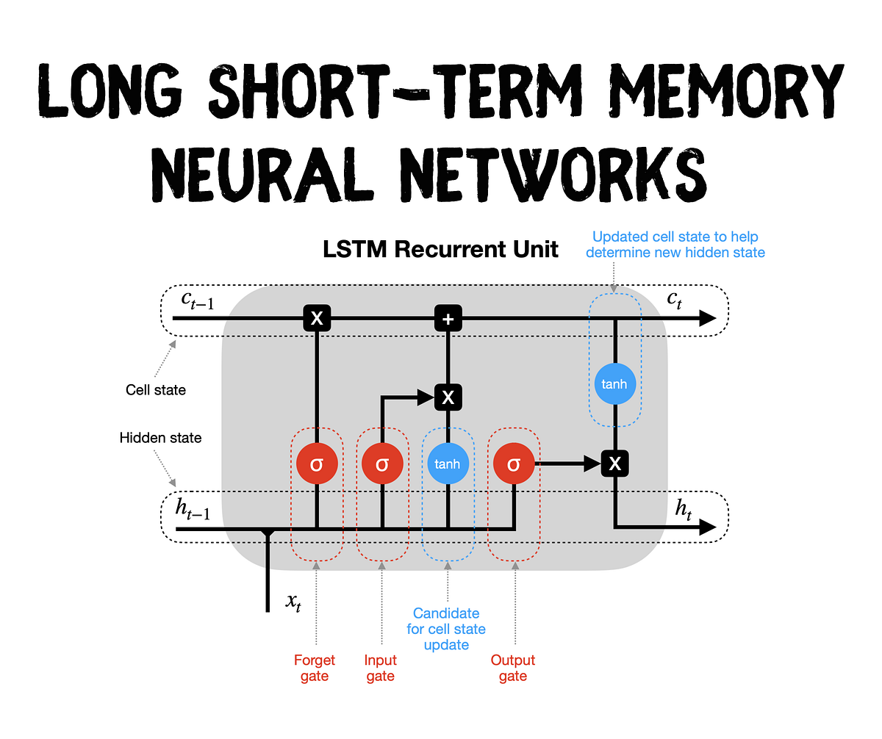

the concept of Long Short-Term Memory (LSTM) in Recurrent Neural Networks (RNNs):

* **Purpose**: LSTM is designed to overcome the limitations of traditional RNNs by capturing long-range dependencies and mitigating the vanishing gradient problem during training.
* **Memory Cells**: It introduces memory cells that store information over time, allowing the network to remember important details over long sequences.
* **Components**:
  + **Forget Gate**: Determines what information to discard from the cell state.
  + **Input Gate**: Controls what new information to store in the cell state.
  + **Output Gate**: Controls what information to output from the cell state.
  + **Cell State**: Represents the internal memory of the cell.
* **Gates Operations**: Each gate uses sigmoid functions to decide how much information to forget, input, or output based on input and previous states.
* **Processing Steps**: Involves updating the cell state based on forget, input, and output gate operations, which helps in retaining and utilizing relevant information over time.
* **Training**: LSTM networks are trained using backpropagation through time (BPTT) to update parameters and learn to capture long-term dependencies effectively.
* **Benefits**: LSTMs are suitable for tasks requiring memory and context, such as language modeling, speech recognition, and time series prediction, due to their ability to retain and utilize information over extended sequences.

In essence, LSTM in RNNs enhances the network's ability to handle sequential data by incorporating memory cells and gating mechanisms, enabling it to learn and remember long-term dependencies, making them valuable for a wide range of applications in machine learning.

1. Sigmoid Function Utilization in Perceptron Model

the utilization of the sigmoid function in the perceptron model:

* **Activation Function**:
  + The sigmoid function is used as the activation function in the perceptron's output layer for binary classification tasks.
* **Output Calculation**:
  + It transforms the weighted sum of inputs into a probability-like output between 0 and 1 using the formula σ(w1x1+w2x2+…+wnxn+b)\sigma(w_1 x_1 + w_2 x_2 + \ldots + w_n x_n + b)σ(w1​x1​+w2​x2​+…+wn​xn​+b).
* **Binary Classification**:
  + The output is interpreted probabilistically: values above 0.5 signify one class, while values below 0.5 signify the other class.
* **Decision Boundary**:
  + The sigmoid function's non-linear transformation helps establish a linear decision boundary in the input space.
* **Training**:
  + During training, the weights and bias are updated using gradient descent, leveraging the differentiability of the sigmoid function.
* **Benefits**:
  + Sigmoid's range of 0 to 1 and differentiability make it suitable for producing probabilities and optimizing the perceptron model through gradient-based methods.

1. Architectural Model for Image Classification using Artificial Neural Networks

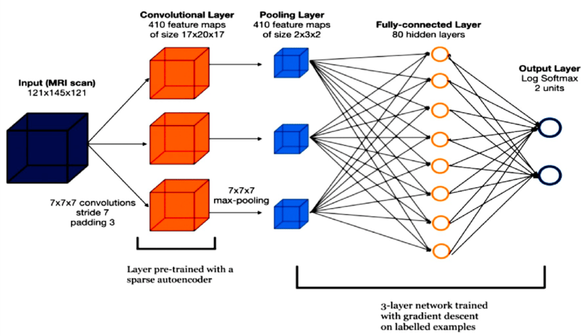

the architectural model for image classification using Artificial Neural Networks (ANNs):

* **Input Layer**: Receives image pixel values.
* **Convolutional Layers**: Extracts features like edges and textures.
* **Pooling Layers**: Reduces dimensions while retaining important information.
* **Flattening Layer**: Converts features to a 1D vector.
* **Fully Connected Layers**: Classifies features using dense layers.
* **Output Layer**: Produces final probabilities for classification.
* **Training**: Uses optimization techniques to minimize loss and improve accuracy.

1. Application of Convergence Theorem for Perceptron Model

he Convergence Theorem is a fundamental concept in machine learning, particularly for models like the perceptron. Here's how it applies to the perceptron model:

1. **Definition**:
   * The Convergence Theorem states that the perceptron learning algorithm converges (i.e., finds a solution) if the training data is linearly separable.
2. **Linear Separability**:
   * Linear separability means that the training data can be separated into classes using a linear decision boundary.
3. **Perceptron Learning Algorithm**:
   * The perceptron learning algorithm adjusts the model's weights iteratively to classify data correctly.
   * It updates weights based on misclassified instances until all instances are classified correctly or a maximum number of iterations is reached.
4. **Convergence**:
   * If the training data is linearly separable, the perceptron algorithm is guaranteed to converge.
   * Convergence means that the algorithm will find weights that correctly classify all training instances.
5. **Implications**:
   * The Convergence Theorem assures that the perceptron model is effective for linearly separable data.
   * For non-linearly separable data, the perceptron algorithm may not converge and may not find a perfect solution.
6. **Usage**:
   * The Convergence Theorem guides the application of the perceptron model in tasks where data can be separated by a linear decision boundary.
   * It helps in understanding the limitations of the perceptron model when dealing with non-linearly separable data.

In summary, the Convergence Theorem for the perceptron model highlights its effectiveness in solving linearly separable classification problems, providing a clear guideline for its application and understanding its limitations when faced with non-linear separability.

1. Identification of Issues in Machine Learning

• **Overfitting**: Model learns training data too closely, leading to poor generalization.

• **Underfitting**: Model is too simple to capture data patterns, resulting in low performance.

• **Data Quality**: Poor-quality data can bias or compromise model reliability.

• **Imbalanced Data**: Unequal class distributions can bias models, requiring special handling.

• **Curse of Dimensionality**: High-dimensional data poses challenges; dimensionality reduction helps.

• **Model Interpretability**: Complex models may lack interpretability, requiring simpler or explainable models.

• **Hyperparameter Tuning**: Optimal hyperparameters are crucial for model performance.

• **Model Evaluation**: Inadequate evaluation metrics or validation techniques can lead to inaccurate assessments.

• **Computational Resources**: Complex models and large datasets require significant computational resources.

1. Working Cycle of Single Layer Perceptron Model

summary of the working cycle of a single-layer perceptron model:

1. **Initialization**: Set initial weights and bias.
2. **Input Processing**: Receive input features.
3. **Weighted Sum Calculation**: Compute z=∑(wi⋅xi)+bz = \sum (w_i \cdot x_i) + bz=∑(wi​⋅xi​)+b.
4. **Activation Function**: Apply step function to zzz to get the output.
5. **Prediction**: Compare output to actual label.
6. **Weight Update**: Adjust weights and bias based on error.
   * wi=wi+η⋅(y−y^)⋅xiw_i = w_i + \eta \cdot (y - \hat{y}) \cdot x_iwi​=wi​+η⋅(y−y^​)⋅xi​
   * b=b+η⋅(y−y^)b = b + \eta \cdot (y - \hat{y})b=b+η⋅(y−y^​)
7. **Iteration**: Repeat for all training examples over multiple epochs.
8. **Convergence**: Achieve correct classification if data is linearly separable.
9. Weight Initialization Techniques in Deep Neural Networks

**Summary of Weight Initialization Techniques in Deep Neural Networks:**

1. **Zero Initialization**:
   * Weights set to zero.
   * **Problem**: Leads to symmetry issues; neurons learn the same features.
2. **Random Initialization**:
   * Weights set to small random values.
   * **Problem**: May cause slow convergence or local minima issues.
3. **Xavier (Glorot) Initialization**:
   * Weights from a distribution with variance based on input/output neurons.
   * **Benefit**: Maintains variance of activations across layers; good for tanh and sigmoid.
4. **He Initialization**:
   * Weights from a distribution with variance scaled by input neurons.
   * **Benefit**: Effective for ReLU activations; improves convergence.
5. **LeCun Initialization**:
   * Weights from a distribution with variance based on input neurons.
   * **Benefit**: Suitable for SELU activations.
6. **Orthogonal Initialization**:
   * Weights using an orthogonal matrix.
   * **Benefit**: Maintains gradient norms; useful for RNNs.
7. **Variance Scaling Initialization**:
   * Weights from a distribution with scaled variance according to layer size.
   * **Benefit**: Balances for various activations and layer sizes.
8. Limitations of Single-layer Perceptron and Introduction to Multilayer Perceptron

**Limitations of Single-layer Perceptron:**

1. **Linearly Separable Data**:
   * Can only solve problems where data is linearly separable.
   * **Example**: Cannot solve XOR problem.
2. **Limited Representation**:
   * Cannot capture complex patterns or relationships in data.
3. **Simple Decision Boundaries**:
   * Only able to create linear decision boundaries.

**Introduction to Multilayer Perceptron (MLP):**

1. **Multiple Layers**:
   * Consists of input, hidden, and output layers.
   * **Benefit**: Can learn complex patterns by adding more layers.
2. **Non-linear Activation Functions**:
   * Uses activation functions like ReLU, Sigmoid, or Tanh in hidden layers.
   * **Benefit**: Allows the network to learn non-linear decision boundaries.
3. **Backpropagation**:
   * Uses backpropagation algorithm to adjust weights.
   * **Benefit**: Efficient learning and error minimization.
4. **Solves Complex Problems**:
   * Capable of solving non-linearly separable problems.
   * **Example**: Can solve XOR problem.

**Summary Points**

* **Single-layer Perceptron**:
  + Only for linearly separable data.
  + Simple, linear decision boundaries.
* **Multilayer Perceptron (MLP)**:
  + Multiple layers for complex pattern learning.
  + Non-linear activations for non-linear decision boundaries.
  + Backpropagation for efficient weight adjustment.
  + Solves complex, non-linearly separable problems.

By using multiple layers and non-linear activation functions, MLPs overcome the limitations of single-layer perceptrons and can handle a wider variety of tasks.

1. Advantages and Disadvantages of Artificial Neural Networks in Time Series Forecasting

summary of the advantages and disadvantages of Artificial Neural Networks (ANNs) in time series forecasting:

| **Aspect** | **Advantages** | **Disadvantages** |
| --- | --- | --- |
| **Non-linear Relationships** | Can model complex, non-linear relationships. | - |
| **Flexibility** | Can handle various types of time series data, including multiple inputs and outputs. | - |
| **Feature Engineering** | Automatically learns and extracts features from raw data. | - |
| **Adaptive Learning** | Adapts to changing patterns in data over time. | - |
| **Pattern Recognition** | Excels at recognizing patterns in data, improving forecast accuracy. | - |
| **Data Requirements** | - | Requires large amounts of data for training. |
| **Computational Complexity** | - | Training can be computationally intensive and time-consuming. |
| **Overfitting** | - | Prone to overfitting, especially with noisy or insufficient data. |
| **Interpretability** | - | Considered "black boxes" with internal workings that are not easily interpretable. |
| **Hyperparameter Tuning** | - | Requires significant experimentation and expertise to find the right architecture and hyperparameters. |

1. Simplification of Learning Rate in Gradient Descent

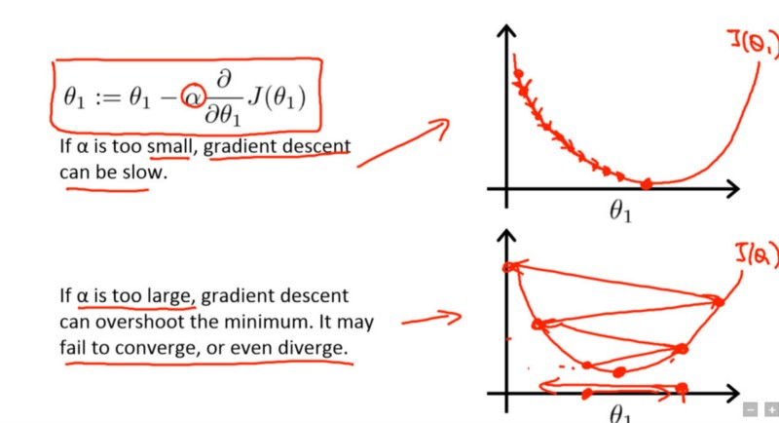

### Simplification of Learning Rate in Gradient Descent

#### Key Points:

1. **Definition**:
   * The learning rate is a hyperparameter that controls how much to adjust the model's weights with respect to the gradient of the loss function during training.
2. **Impact**:
   * **High Learning Rate**:
     + **Pros**: Faster convergence.
     + **Cons**: Risk of overshooting the optimal point, leading to divergent or unstable training.
   * **Low Learning Rate**:
     + **Pros**: More precise convergence.
     + **Cons**: Slower training and risk of getting stuck in local minima.
3. **Choosing Learning Rate**:
   * Often involves experimentation and tuning.
   * Techniques like learning rate schedules or adaptive learning rates (e.g., Adam optimizer) can help.
4. **Learning Rate Schedules**:
   * Reduce learning rate over time or based on performance metrics.
   * Examples: Step decay, exponential decay, and adaptive learning rate methods.

### Summary in Simplified Terms:

* **What It Is**: A setting that tells the model how much to change weights in response to the loss during training.
* **Why It Matters**:
  + **Too High**: Training may be fast but can become unstable.
  + **Too Low**: Training is slow but more stable.
* **How to Find the Right One**: Try different values, use techniques that adjust it over time.

1. Critique of Activation Functions in Different Scenarios

**Critique of Activation Functions in Different Scenarios**

|  |  |  |  |  |
| --- | --- | --- | --- | --- |
| **Activation Function** | **Description** | **Advantages** | **Disadvantages** | **Best Use Cases** |
| Sigmoid (σ(x) = 1 / (1 + e^(-x))) | Smooth gradient, Output range (0, 1), Good for binary classification | Vanishing gradient problem, Outputs not zero-centered, Slow convergence | Binary classification, Output layer for binary predictions |  |
| Tanh (tanh(x) = (e^x - e^(-x)) / (e^x + e^(-x))) | Zero-centered output, Stronger gradients than sigmoid | Vanishing gradient problem | Hidden layers in feedforward neural networks |  |
| ReLU (ReLU(x) = max(0, x)) | Sparse activation (efficient computation), Mitigates vanishing gradient problem | Dying ReLU problem (neurons can "die" during training) | Hidden layers in deep neural networks, Convolutional neural networks |  |
| Leaky ReLU (Leaky ReLU(x) = max(0.01x, x)) | Fixes dying ReLU problem, Allows small gradient when x < 0 | Not zero-centered output | Hidden layers in deep neural networks, Alternative to ReLUs |  |
| Softmax (Softmax(x_i) = e^(x_i) / Σ(j)e^(x_j)) | Converts logits to probabilities, Sum of outputs is 1 | Not suitable for hidden layers, Computationally expensive for many classes | Output layer for multi-class classification |  |
| ELU (ELU(x) = x if x > 0; ELU(x) = α(e^x - 1) if x ≤ 0) | Outputs can be negative, Helps mitigate vanishing gradient problem | Computationally expensive | Deep neural networks, Alternative to ReLU |  |

**Summary Points:**

* Sigmoid: Good for binary classification but suffers from vanishing gradients and slow convergence.
* Tanh: Preferred over sigmoid for hidden layers due to zero-centered output but still has vanishing gradient issues.
* ReLU: Popular for deep networks due to its efficiency and mitigation of vanishing gradients but can suffer from the "dying ReLU" problem.
* Leaky ReLU: Addresses the dying ReLU issue by allowing small gradients for negative inputs, making it a robust alternative to ReLU.
* Softmax: Ideal for the output layer in multi-class classification problems as it provides a probability distribution over classes.
* ELU: Combines benefits of ReLU and sigmoid/tanh by allowing negative outputs and reducing the vanishing gradient problem, though it is computationally more expensive.

1. Challenges with Vanishing Gradients in RNNs and Role of LSTM

### Challenges with Vanishing Gradients in RNNs and Role of LSTM

#### Vanishing Gradients in RNNs:

1. **Definition**:
   * In recurrent neural networks (RNNs), the vanishing gradient problem occurs when gradients (used for updating model weights) become very small during backpropagation.
2. **Impact**:
   * **Learning Slows Down**: Small gradients mean that weight updates are tiny, causing the learning process to slow down or even stop.
   * **Difficulty in Learning Long-term Dependencies**: RNNs struggle to connect earlier information with later information in a sequence, which is critical for tasks like language modeling or time series prediction.
3. **Why It Happens**:
   * During backpropagation, gradients are multiplied through the network's layers. If these gradients are less than 1, they shrink exponentially, leading to very small values.

#### Role of LSTM (Long Short-Term Memory):

1. **Introduction**:
   * LSTMs are a special kind of RNN designed to overcome the vanishing gradient problem and learn long-term dependencies.
2. **Key Features**:
   * **Cell State**: LSTMs have a cell state that runs through the entire network, allowing information to flow unchanged.
   * **Gates**: LSTMs use gates (forget gate, input gate, and output gate) to control the flow of information.
3. **Gates Explained**:
   * **Forget Gate**: Decides what information to discard from the cell state.
   * **Input Gate**: Determines what new information to add to the cell state.
   * **Output Gate**: Controls what information from the cell state to output.
4. **Benefits**:
   * **Maintains Long-term Dependencies**: By allowing gradients to flow unchanged, LSTMs can learn long-term dependencies.
   * **Avoids Vanishing Gradients**: The structure of LSTMs prevents gradients from shrinking, ensuring effective training.

### Summary in Simple Terms:

* **Vanishing Gradients in RNNs**:
  + **Problem**: Gradients get very small, slowing down learning and making it hard to remember long-term information.
  + **Impact**: RNNs can't effectively learn patterns over long sequences of data.
* **LSTMs to the Rescue**:
  + **Solution**: LSTMs have a cell state and gates to manage the flow of information.
  + **Benefits**: They can remember important information over long periods and prevent gradients from vanishing, making learning efficient and effective.

By addressing the vanishing gradient problem, LSTMs enable RNNs to handle tasks requiring long-term memory, such as language translation and time series prediction.

1. Implementation of Convolutional Neural Network (CNN) for Image Classification

### Example Code Snippet (in TensorFlow/Keras):

import tensorflow as tf

from tensorflow.keras import layers, models

# Define the CNN model

model = models.Sequential([

layers.Conv2D(32, (3, 3), activation='relu', input_shape=(64, 64, 3)),

layers.MaxPooling2D((2, 2)),

layers.Conv2D(64, (3, 3), activation='relu'),

layers.MaxPooling2D((2, 2)),

layers.Conv2D(128, (3, 3), activation='relu'),

layers.MaxPooling2D((2, 2)),

layers.Flatten(),

layers.Dense(128, activation='relu'),

layers.Dense(10, activation='softmax')

])

# Compile the model

model.compile(optimizer='adam',

loss='categorical_crossentropy',

metrics=['accuracy'])

# Train the model

model.fit(train_images, train_labels, epochs=10, batch_size=32, validation_data=(val_images, val_labels))

# Evaluate the model

test_loss, test_acc = model.evaluate(test_images, test_labels)

print(f'Test Accuracy: {test_acc}')

1. Contributions of Dropout, DropConnect, and Batch Normalization in Deep Learning

the contributions of Dropout, DropConnect, and Batch Normalization in deep learning using easy-to-understand language:

**Dropout:**

* **What It Does**: Dropout randomly deactivates some neurons during training, forcing the network to learn redundant representations and reducing overfitting.
* **Contribution**:
  + **Reduces Overfitting**: By preventing neurons from relying too much on specific features, Dropout improves generalization and reduces overfitting.
  + **Improves Robustness**: Dropout makes the model more robust by preventing it from memorizing noise in the training data.
* **Example**:
  + Imagine studying for a test where you sometimes cover up parts of your notes. This forces you to understand the material better and not rely on memorization alone.

**DropConnect:**

* **What It Does**: DropConnect randomly sets connections between neurons to zero during training, similar to Dropout but at the connection level.
* **Contribution**:
  + **Enhances Regularization**: DropConnect acts as a stronger form of regularization than Dropout by also varying connections between layers.
  + **Improves Generalization**: Like Dropout, it helps the model generalize better by preventing it from learning spurious correlations.
* **Example**:
  + Think of building a network of pipes where some pipes randomly get blocked during water flow tests. This ensures that the system is robust and doesn't rely too much on specific paths.

**Batch Normalization:**

* **What It Does**: Batch Normalization normalizes the inputs of each layer to have zero mean and unit variance, improving training stability and speed.
* **Contribution**:
  + **Stabilizes Training**: Batch Normalization helps stabilize training by reducing internal covariate shift, making optimization more consistent.
  + **Speeds Up Training**: It accelerates training by allowing higher learning rates and reducing the need for careful initialization.
* **Example**:
  + Imagine cooking where you adjust the ingredients' proportions based on the batch size, ensuring consistent taste and faster cooking times.

**Summary:**

* **Dropout** and **DropConnect** combat overfitting by introducing randomness during training, while **Batch Normalization** stabilizes and accelerates training by normalizing inputs.
* Together, they contribute to more robust, faster, and better-performing deep learning models.

1. Difference Between Gradient Descent and Stochastic Gradient Descent

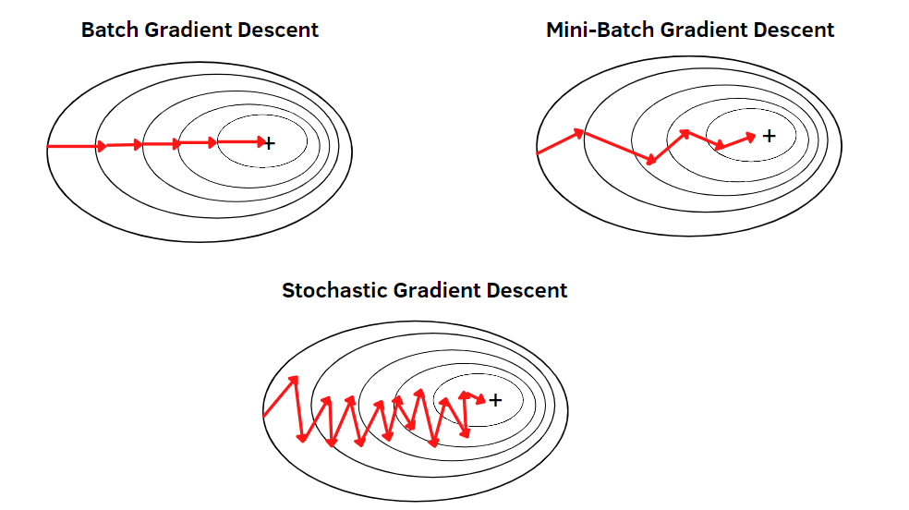

comparison between Gradient Descent (GD) and Stochastic Gradient Descent (SGD):

| **Aspect** | **Gradient Descent (GD)** | **Stochastic Gradient Descent (SGD)** |
| --- | --- | --- |
| Processing Data | Processes entire dataset (batch processing) | Processes one training example at a time (online processing) |
| Update Frequency | Less frequent updates, accurate gradients | More frequent updates, noisy gradients |
| Convergence | Stable convergence but slower | Faster convergence but less stable |
| Computational Efficiency | Computationally expensive for large datasets | More efficient for large datasets |
| Noise in Updates | Less noisy updates | More noisy updates, prone to oscillations |
| Escape Local Minima | May get stuck in local minima | Can escape local minima more easily |

1. Comparison between Linear and Non-linear Activation Functions

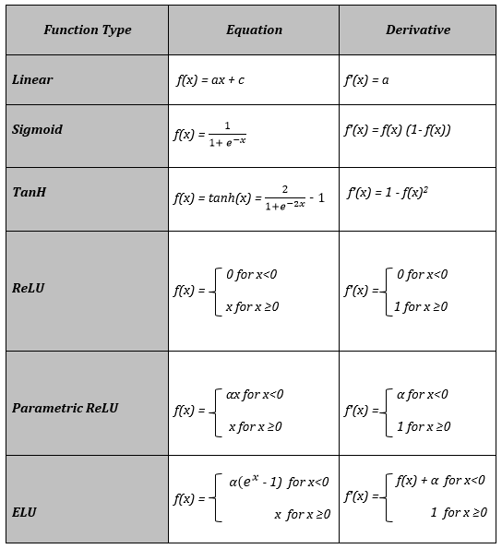

comparison between Linear and Non-linear Activation Functions in neural networks:

| **Aspect** | **Linear Activation Functions** | **Non-linear Activation Functions** |
| --- | --- | --- |
| Definition | f(x)=cxf(x) = cxf(x)=cx where ccc is a constant | Functions that introduce non-linearity in the network, such as Sigmoid, ReLU, Tanh, etc. |
| Linearity | Always produce a straight line | Introduce curves and bends, allowing complex mappings |
| Output Range | Output is directly proportional to the input | Output is not directly proportional to the input |
| Complexity Handling | Limited ability to handle complex patterns | Capable of learning complex relationships and patterns |
| Use Cases | Rarely used in hidden layers due to limited expressive power | Widely used in hidden layers for learning non-linear representations |
| Network Behavior | Linear functions result in linear networks | Non-linear functions allow networks to learn more complex representations |
| Vanishing/Exploding Gradients | Less prone to vanishing or exploding gradients | Can suffer from vanishing or exploding gradients, depending on the function |
| Example Functions | Identity function f(x)=xf(x) = xf(x)=x, Linear function f(x)=cxf(x) = cxf(x)=cx | Sigmoid f(x)=11+e−xf(x) = \frac{1}{1 + e^{-x}}f(x)=1+e−x1​, ReLU f(x)=max⁡(0,x)f(x) = \max(0, x)f(x)=max(0,x), Tanh f(x)=e2x−1e2x+1f(x) = \frac{e^{2x} - 1}{e^{2x} + 1}f(x)=e2x+1e2x−1​ |

**Summary:**

* **Linearity**: Linear activation functions produce straight lines, while non-linear functions introduce curves and bends.
* **Complexity Handling**: Non-linear functions can handle complex patterns and relationships, unlike linear functions.
* **Use Cases**: Linear functions are rarely used in hidden layers, whereas non-linear functions are essential for learning non-linear representations.
* **Network Behavior**: Linear functions result in linear networks, while non-linear functions allow networks to learn complex mappings.
* **Gradients**: Linear functions are less prone to vanishing or exploding gradients compared to some non-linear functions like Sigmoid.

1. Conditions for Applying Gradient Descent

To apply Gradient Descent effectively, certain conditions should ideally be met:

1. **Differentiability**: The cost function with respect to the model parameters must be differentiable. This allows the calculation of gradients, which are essential for updating the model parameters in the direction of minimizing the cost.
2. **Smoothness**: The cost function should be smooth and continuous to ensure that small changes in the parameters result in predictable changes in the cost. This smoothness helps Gradient Descent converge more efficiently towards the optimal solution.
3. **Convexity (for convex optimization)**: In convex optimization problems, the cost function has a single global minimum, making it easier for Gradient Descent to converge to the optimal solution. However, many real-world problems are non-convex, where Gradient Descent may converge to a local minimum or saddle point instead of the global minimum.
4. **Learning Rate Selection**: The learning rate, which determines the size of parameter updates, should be chosen carefully. If the learning rate is too large, Gradient Descent may overshoot the minimum or oscillate around it. Conversely, if the learning rate is too small, convergence may be slow.
5. **Training Data Representation**: The training data should be representative of the underlying distribution to ensure that the learned model generalizes well to unseen data. Biased or insufficient data can lead to poor model performance even with Gradient Descent optimization.
6. **Regularization Techniques**: In cases of overfitting, regularization techniques like L1 or L2 regularization can be applied alongside Gradient Descent to prevent the model from fitting the training data too closely and improve generalization.
7. **Mini-batch or Stochastic Gradient Descent (optional)**: For large datasets, mini-batch or stochastic variants of Gradient Descent can be used to speed up training by processing subsets of data or individual data points at each iteration.
8. Limitations of Zero Initialization of Weights in Neural Networks

Zero initialization of weights in neural networks has several limitations that can affect the training process and model performance:

1. **Symmetry Breaking**: When all weights are initialized to zero, all neurons in a layer will compute the same output during forward propagation and receive the same gradients during backpropagation. This symmetry can prevent the network from learning diverse representations and hinder its ability to capture complex patterns in the data.
2. **Vanishing Gradient**: Initialization with all zeros can lead to vanishing gradients, especially in deep networks. Gradients near zero result in negligible weight updates, causing slow or stalled learning. This is particularly problematic for activation functions like sigmoid or tanh that saturate for large inputs, leading to vanishing gradients.
3. **Sparse Representations**: Zero-initialized weights can result in sparse representations, where many neurons remain inactive (outputting zeros) for most inputs. Sparse activations may limit the model's capacity to learn rich features and reduce its expressive power.
4. **Initialization Bias**: Zero initialization introduces a bias towards certain types of functions, especially when combined with certain activation functions like ReLU. For example, ReLU neurons with zero-initialized weights will remain inactive for inputs below zero, affecting the model's ability to capture negative-valued patterns effectively.
5. **Impact on Network Dynamics**: Zero-initialized weights can influence the dynamics of the network during training, potentially causing issues like exploding or unstable gradients, especially in deep architectures.
6. **Lack of Randomness**: Random initialization introduces diversity in weights, helping the model explore different regions of the parameter space and escape local minima. Zero initialization lacks this randomness, making the optimization process more deterministic and less exploratory.

To address these limitations, techniques such as Xavier/Glorot initialization, He initialization, or custom initialization schemes are often used. These methods aim to initialize weights in a way that promotes stable training, avoids symmetry issues, and encourages effective learning of complex patterns in the data.

1. Architecture and Limitations of Feedforward Neural Networks

**Architecture of Feedforward Neural Networks (FNNs):**

1. **Components**: FNNs consist of input layers, hidden layers (which perform computations), and output layers.
2. **Neurons**: Neurons in hidden layers compute weighted sums of inputs and apply activation functions.
3. **Output Layer**: Neurons in the output layer represent predictions or classifications.

**Limitations of Feedforward Neural Networks (FNNs):**

1. **Lack of Context**: FNNs lack memory and context, making them less suitable for sequential data processing.
2. **Overfitting**: Without regularization, FNNs can overfit training data, leading to poor generalization on unseen data.
3. **Gradient Issues**: Deep FNNs may encounter vanishing or exploding gradient problems during training.
4. **Feature Engineering**: FNNs require manual feature engineering and struggle with learning features from raw data.
5. **Non-linear Separability**: They face challenges with non-linearly separable data without appropriate activation functions or layers.
6. **Interpretability**: Understanding FNN decisions can be complex due to their architecture and parameters.
7. Working of Various Activation Functions in Neural Networks

• **Sigmoid Function**:

* **Range**: Outputs values between 0 and 1.
* **Working**: Squashes input values to a range suitable for binary classification or probability estimation. However, it suffers from vanishing gradients, especially for extreme input values.

• **Hyperbolic Tangent (Tanh) Function**:

* **Range**: Outputs values between -1 and 1.
* **Working**: Similar to the sigmoid function but centered at 0, which helps with faster convergence in some cases. However, it still suffers from vanishing gradients.

• **Rectified Linear Unit (ReLU)**:

* **Range**: Outputs 0 for negative values and the input value for positive values.
* **Working**: Overcomes the vanishing gradient problem for positive values, leading to faster training. However, it can suffer from "dying ReLU" where neurons output 0 indefinitely.

• **Leaky ReLU**:

* **Range**: Outputs a small negative value for negative inputs and the input value for positive inputs.
* **Working**: Addresses the "dying ReLU" problem by allowing a small gradient for negative inputs, which helps maintain non-zero gradients and prevents neurons from becoming inactive.

• **Parametric ReLU (PReLU)**:

* **Range**: Similar to Leaky ReLU but the negative slope is learnable.
* **Working**: Allows the network to learn an optimal negative slope for negative inputs during training, enhancing flexibility.

• **Exponential Linear Unit (ELU)**:

* **Range**: Outputs the input value for positive inputs and a negative exponential for negative inputs.
* **Working**: Similar to ReLU but smoother and can handle negative inputs more gracefully, reducing the likelihood of "dying neurons."

• **Swish Function**:

* **Range**: Combines features of ReLU and Sigmoid functions.
* **Working**: Scales input values by a sigmoid function, introducing non-linearity while maintaining smoothness and addressing the vanishing gradient problem.

• **Softmax Function**:

* **Range**: Outputs a probability distribution over multiple classes (sum of outputs is 1).
* **Working**: Used in the output layer of classification networks to predict probabilities for each class, making it suitable for multi-class classification tasks.

1. Classification vs. Regression in Machine Learning

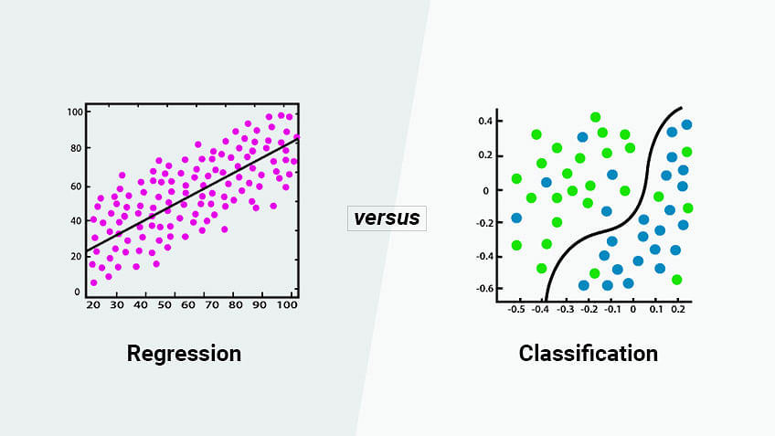

comparison between classification and regression in tabular format:

| **Aspect** | **Classification** | **Regression** |
| --- | --- | --- |
| Objective | Classify data into discrete categories or classes | Predict continuous numerical values |
| Output | Class labels (e.g., "cat," "dog," "car") | Numerical values (e.g., price, temperature) |
| Types | Binary classification, multi-class classification | Simple linear regression, multiple regression |
| Algorithms | Logistic Regression, SVM, Random Forest | Linear Regression, Decision Trees, Gradient Boosting |
| Evaluation Metrics | Accuracy, Precision, Recall, F1-score | Mean Squared Error (MSE), Root Mean Squared Error (RMSE), Mean Absolute Error (MAE) |
| Examples | Spam email detection, image classification | House price prediction, stock price forecasting |

1. Explanation of Transfer Functions in Deep Learning

Transfer functions, also known as activation functions, are crucial in deep learning for introducing non-linearity into neural networks. Here's a summary of common transfer functions and their roles:

1. **Linear Transfer Function**: Represents a simple identity function but not commonly used in hidden layers as it results in a linear combination of inputs.
2. **Non-linear Transfer Functions**: Introduce non-linearity, enabling networks to learn complex patterns.
   * **Sigmoid Function**: Outputs values between 0 and 1, suitable for binary classification but suffers from vanishing gradients.
   * **Hyperbolic Tangent (Tanh) Function**: Outputs values between -1 and 1, overcoming the zero-centered problem but still facing vanishing gradient issues.
   * **Rectified Linear Unit (ReLU)**: Outputs 0 for negative values and the input value for positive values, widely used due to simplicity and mitigating vanishing gradient problems.
   * **Leaky ReLU**: Introduces a small slope for negative inputs, preventing neurons from becoming inactive.
   * **Exponential Linear Unit (ELU)**: Smoother transitions for negative inputs, reducing the likelihood of "dying neurons."
   * **Softmax Function**: Used in the output layer for multi-class classification tasks, providing a probability distribution over classes.

These functions enable neural networks to learn complex relationships in data effectively, and the choice depends on the problem's characteristics and network architecture.

1. Image Classification Models in Deep Learning

Image classification models in deep learning are designed to categorize images into predefined classes. Here's a summary of common models:

1. **Convolutional Neural Networks (CNNs)**:
   * Specialized for image tasks, using convolutional layers to extract features.
   * Examples include LeNet-5, AlexNet, VGGNet, GoogLeNet (Inception), ResNet, and DenseNet.
   * Pre-trained models like VGG16, ResNet50 are often used with transfer learning.
2. **MobileNet**:
   * Designed for mobile devices, using depthwise separable convolutions for efficiency.
3. **Inception (GoogLeNet)**:
   * Utilizes inception modules for capturing features at different scales.
4. **Residual Networks (ResNets)**:
   * Addresses vanishing gradients with skip connections or residual blocks.
5. **DenseNet**:
   * Employs dense connectivity between layers for better feature propagation.
6. **EfficientNet**:
   * Balances model depth, width, and resolution for efficiency and accuracy.
7. **VGGNet**:
   * Known for simplicity and uniform architecture with small filters (3x3).
8. **Xception**:
   * Based on Inception but uses depthwise separable convolutions.

These models vary in complexity and efficiency, suitable for different datasets and deployment scenarios. Transfer learning is common for adapting pre-trained models to specific image classification tasks.

1. Performance Measures for Classification in Deep Learning

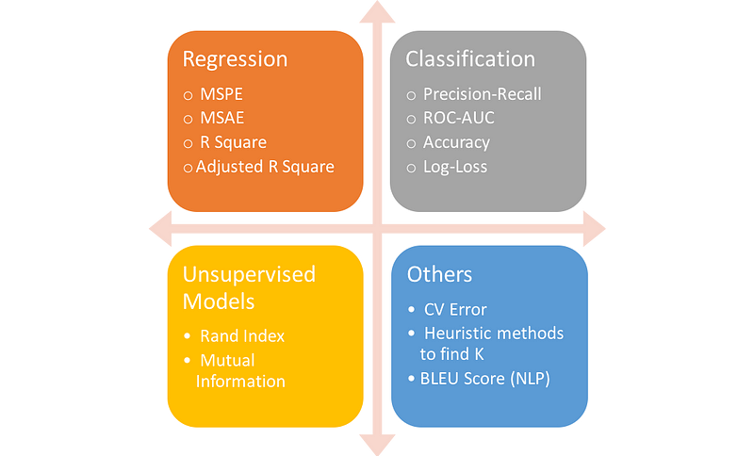

Performance measures for classification in deep learning assess how accurately a model predicts class labels. Here's a summary:

1. **Accuracy**: Measures the overall correctness of predictions but can be misleading for imbalanced datasets.
2. **Precision**: Evaluates the proportion of true positive predictions among all positive predictions, helping to identify false positives.
3. **Recall (Sensitivity)**: Assesses the proportion of true positive predictions among all actual positives, indicating the model's ability to capture all positive instances.
4. **F1 Score**: Harmonic mean of precision and recall, providing a balanced measure, especially useful for imbalanced datasets.
5. **Specificity (True Negative Rate)**: Measures the proportion of true negative predictions among all actual negatives, important in scenarios where correctly identifying negatives is crucial.
6. **ROC Curve and AUC**: Graphical representation and area under the curve measure the model's ability to distinguish between classes.
7. **Confusion Matrix**: Tabulates true positive, true negative, false positive, and false negative predictions, offering insights into the model's performance across different classes.
8. **Precision-Recall Curve**: Graphical representation of precision against recall, particularly useful for evaluating models in imbalanced datasets.
9. Supervised vs. Unsupervised Deep Learning Procedures

comparing supervised and unsupervised deep learning procedures:

| **Aspect** | **Supervised Learning** | **Unsupervised Learning** |
| --- | --- | --- |
| Objective | Predict output labels from input data | Discover patterns or structures |
| Training Data | Labeled input-output pairs | Unlabeled input data |
| Examples | Image classification, sentiment analysis | Clustering, dimensionality reduction |
| Training Process | Learns mapping from input to output | Identifies hidden patterns |
| Evaluation | Accuracy, precision, recall, F1 score | Qualitative assessment, domain-specific metrics |
| Key Characteristics | Requires labeled data | Works with unlabeled data |

1. Distinction Between LSTM and Gated Recurrent Units

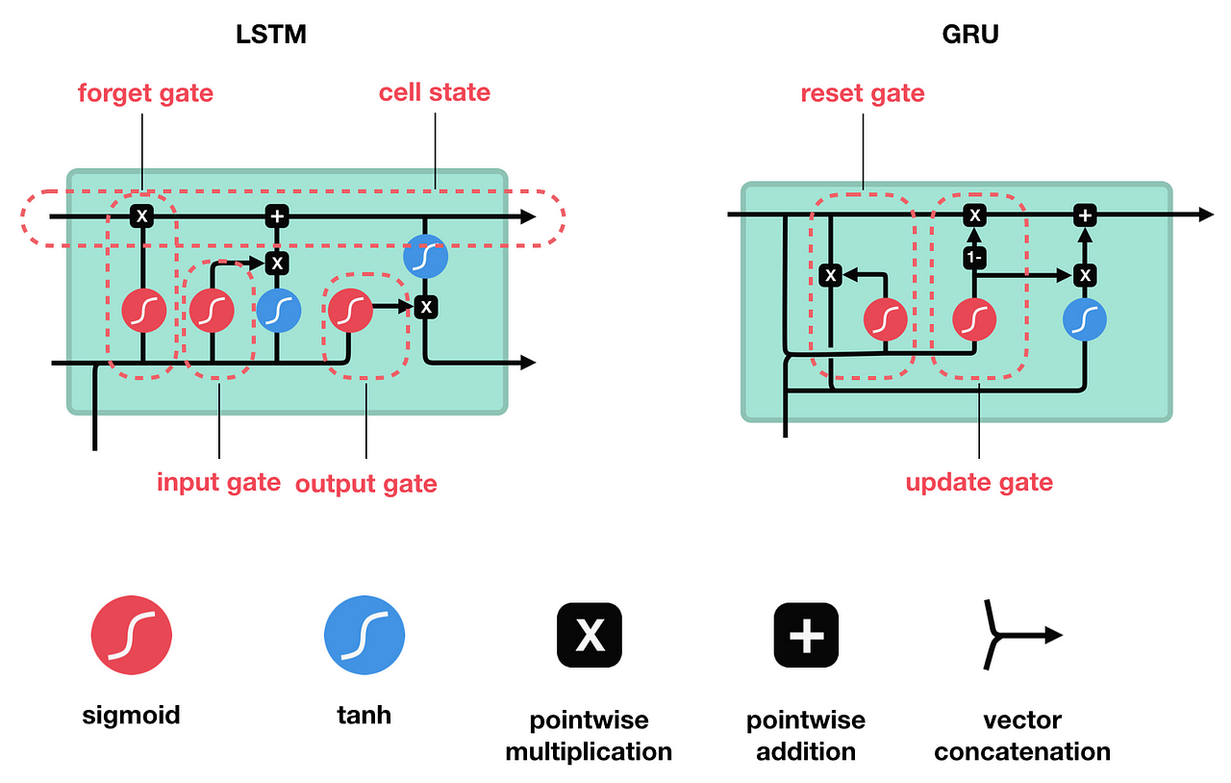

comparison between LSTM (Long Short-Term Memory) and GRU (Gated Recurrent Unit):

| **Aspect** | **LSTM** | **GRU** |
| --- | --- | --- |
| Structure | More complex with separate input, forget, and output gates along with cell state | Simpler with reset and update gates, merging input and forget gate functionality |
| Memory Management | Explicitly manages long-term memory with a dedicated cell state | Merges short-term and long-term memory in a single state vector |
| Gate Mechanisms | Uses input gate, forget gate, and output gate | Combines update gate (z) and reset gate (r) |
| Computational Complexity | Higher computational cost due to additional gates and cell state management | Lower computational cost due to simplified gate structure |
| Information Retention | Efficiently retains information over long sequences | Slightly less effective in handling long dependencies |
| Training Efficiency | Requires more data and computational resources for training | Faster training and convergence due to simpler structure |
| Usage | Commonly used in tasks requiring long-term memory and handling vanishing gradients | Preferred in scenarios where computational resources are limited and simpler models are sufficient |

Both LSTM and GRU are variants of recurrent neural networks (RNNs) designed to address the vanishing gradient problem and capture long-term dependencies in sequential data. The choice between LSTM and GRU depends on factors like computational resources, the complexity of the task, and the trade-off between memory management and computational efficiency.

1. Discussion on Momentum Optimizer in Deep Learning

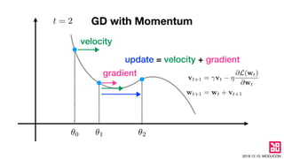

1. **Concept**: Momentum is like a shopping cart with inertia, rolling smoothly even after you stop pushing, thanks to a weighted average of past gradients.
2. **Benefits**:
   * Faster Convergence: Helps the optimizer reach the minimum quicker, especially with noisy gradients.
   * Reduced Oscillations: Prevents bouncing around and getting stuck in local minima.
3. **Implementation**: Consider both current and past gradients to maintain a consistent direction towards the minimum.
4. **Visualization**: Visualize Momentum as a smoother roll down a bumpy landscape (loss function) compared to standard gradient descent.
5. **Key Points**:
   * Uses past gradients to smooth out updates and avoid oscillations.
   * Overcomes noisy data and local minima for faster convergence.
   * Popular in deep learning optimization due to its effectiveness.

In essence, Momentum adds a little extra push in the right direction, helping optimize deep learning models more efficiently.

1. Importance of Hidden State in Recurrent Neural Networks

the hidden state in recurrent neural networks (RNNs) summarized:

1. **Memory and Sequential Information**: The hidden state acts as a memory that retains information from previous time steps, allowing RNNs to capture sequential dependencies in data.
2. **Long-Term Dependencies**: It enables RNNs to learn and remember long-term dependencies in sequences, crucial for tasks like language modeling and time series prediction.
3. **Feature Representation**: The hidden state represents learned features extracted from the input sequence, aiding in making predictions or generating output.
4. **Contextual Understanding**: By considering the entire history of the input sequence, the hidden state provides contextual understanding, improving decision-making based on sequence structure.
5. **Gradient Flow and Training**: It influences the gradient flow during training, propagating information and errors through time, essential for effective learning and model training.
6. **Model Flexibility**: Variants like LSTM and GRU enhance the hidden state's capabilities with additional mechanisms, allowing RNNs to adapt to different sequential tasks and data types.
7. Definition and Significance of Thresholding in Image Processing

Thresholding in image processing is a technique used to segment images by converting them into binary images. Here's the definition and significance of thresholding:

1. **Definition**:
   * Thresholding is the process of converting grayscale or color images into binary images, where each pixel is classified as either black (0) or white (1) based on a threshold value.
   * Pixels with intensities below the threshold are set to black, while those above the threshold are set to white.
2. **Significance**:
   * **Image Segmentation**: Thresholding is fundamental for segmenting objects or regions of interest in images. It separates foreground objects from the background, making it easier to analyze specific areas.
   * **Noise Reduction**: By converting images into binary form, thresholding can help reduce noise and simplify the image, making it more suitable for further processing and analysis.
   * **Feature Extraction**: Thresholding can be used to extract specific features or patterns from images, such as edges, contours, or regions with certain intensity levels.
   * **Object Detection and Recognition**: In tasks like object detection and recognition, thresholding can help isolate objects from complex backgrounds, improving the accuracy of detection algorithms.
   * **Image Preprocessing**: Thresholding is often used as a preprocessing step before applying more advanced image processing techniques like edge detection, morphology, or object tracking.
3. Basic Concept of Linear Separability in Classification Problems

Linear separability in classification refers to the capability of separating classes in a dataset using a straight line or plane. Here's a summary:

1. **Definition**: Linear separability means classes can be cleanly divided by a linear boundary, such as a line in 2D or a hyperplane in higher dimensions.
2. **Binary Classification**: It's crucial in binary classification tasks where data points are categorized into two classes based on features.
3. **Mathematical Representation**: Represented by a linear equation involving weights, features, and a bias term, the boundary separates classes effectively.
4. **Examples**: For instance, in a 2D dataset, linear separability allows a single line to separate data points of different classes.
5. **Importance**: Linearly separable data suits linear classifiers like logistic regression and linear SVMs, simplifying classification tasks.
6. **Challenges**: Not all datasets are linearly separable; complex or nonlinear models are needed for such cases.
7. Overview of Different Types of Transfer Functions in Neural Networks

Transfer functions, also known as activation functions, are essential components in neural networks that introduce nonlinearity into the network, allowing it to learn complex patterns and relationships in data. Here's an overview of different types of transfer functions in neural networks:

1. **Step Function**:
   * Outputs binary values (0 or 1) based on a threshold.
   * Simplest form of activation function, used in perceptrons and binary classifiers.
2. **Linear Function**:
   * Outputs values proportional to the input.
   * Rarely used in hidden layers due to limited learning capacity (linearity).
3. **Sigmoid Function**:
   * S-shaped curve, squashes input values into the range (0, 1).
   * Used in binary classification tasks and as a gate function in LSTMs.
4. **Hyperbolic Tangent (Tanh) Function**:
   * Similar to the sigmoid but outputs values in the range (-1, 1).
   * Useful for centering data around zero, often used in hidden layers.
5. **Rectified Linear Unit (ReLU)**:
   * Outputs zero for negative inputs and linearly for positive inputs.
   * Widely used in deep learning due to faster convergence and reduced vanishing gradient problem.
6. **Leaky ReLU**:
   * Similar to ReLU but allows a small, non-zero gradient for negative inputs.
   * Addresses the "dying ReLU" problem where neurons can become inactive.
7. **Exponential Linear Unit (ELU)**:
   * Similar to ReLU but with smoother behavior for negative inputs.
   * Introduces a small negative slope for negative inputs, helping convergence.
8. **Parametric ReLU (PReLU)**:
   * Variation of Leaky ReLU where the slope for negative inputs is learned during training.
   * Offers more flexibility and improved performance in some cases.
9. **Scaled Exponential Linear Unit (SELU)**:
   * Self-normalizing activation function that maintains mean and variance of inputs close to zero and one, respectively.
   * Particularly effective in deep neural networks and can improve stability and convergence.
10. **Swish Function**:
    * Activation function that combines features of ReLU and sigmoid functions.
    * Can offer better performance than ReLU in some scenarios.

Advanced optimization methods for neural networks (Adagrad, rmsprop, adam

three advanced optimization methods commonly used in training neural networks: Adagrad, RMSProp, and Adam.

1. **Adagrad (Adaptive Gradient Algorithm)**:
   * **Concept**: Adagrad adapts the learning rate of each parameter based on the historical gradients for that parameter.
   * **Algorithm**:
     + It maintains a per-parameter learning rate that decreases over time.
     + Parameters with large gradients have a smaller effective learning rate, while parameters with small gradients have a larger effective learning rate.
   * **Advantages**:
     + Automatically adapts learning rates based on the gradient magnitudes, suitable for sparse data.
     + Often converges faster than traditional stochastic gradient descent (SGD) for convex problems.
   * **Disadvantages**:
     + Accumulation of squared gradients in the denominator can lead to diminishing learning rates, making it less effective for non-convex problems.
2. **RMSProp (Root Mean Square Propagation)**:
   * **Concept**: RMSProp is an extension of Adagrad that addresses its diminishing learning rates issue by using a moving average of squared gradients.
   * **Algorithm**:
     + It maintains a decaying average of squared gradients for each parameter.
     + The learning rate is divided by the root mean square of these squared gradients.
   * **Advantages**:
     + Resolves the diminishing learning rate problem of Adagrad, making it suitable for non-convex optimization problems.
     + Efficiently adjusts learning rates for different parameters based on recent gradient magnitudes.
   * **Disadvantages**:
     + Requires tuning of additional hyperparameters such as the decay rate of the moving average.
3. **Adam (Adaptive Moment Estimation)**:
   * **Concept**: Adam combines the benefits of both Adagrad and RMSProp by using adaptive learning rates and momentum.
   * **Algorithm**:
     + It maintains exponentially decaying averages of past gradients and squared gradients for each parameter.
     + The learning rate is adaptively scaled based on the magnitude of these averages, and momentum is incorporated to accelerate convergence.
   * **Advantages**:
     + Efficiently combines the benefits of adaptive learning rates and momentum, making it suitable for a wide range of optimization problems.
     + Converges quickly and is robust to different types of neural network architectures and data.
   * **Disadvantages**:
     + Requires tuning of hyperparameters such as the learning rate, decay rates, and momentum parameters.

In summary, Adagrad adapts learning rates based on historical gradients, RMSProp addresses its drawbacks by using a moving average of squared gradients, and Adam combines adaptive learning rates with momentum for efficient optimization of neural networks. Choosing the right optimization method depends on the specific characteristics of the problem and the network architecture.

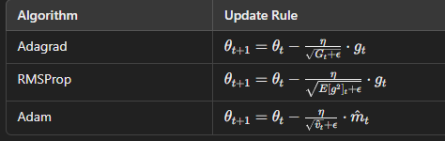

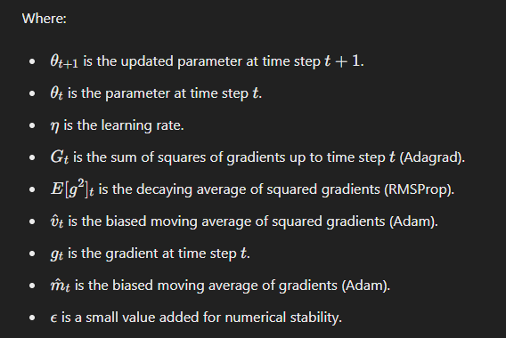

Saddle point problem in neural networks

imagine you're hiking in a mountainous area, looking for the highest peak (the best solution) on the landscape (optimization problem). However, you encounter a flat region (saddle point) where the terrain is neither going up nor down, making it challenging to determine if you've reached the highest point or not.

In neural networks, a similar issue occurs at saddle points during optimization. Here's an easy-to-understand explanation of the saddle point problem:

1. **What is a Saddle Point?**
   * In optimization landscapes, a saddle point is a point where the gradient (slope) is zero but isn't an optimal solution.
   * It's like being stuck on a flat area of the terrain, unsure if you're at the peak or just on a plateau.
2. **Why are Saddle Points a Problem?**
   * Neural networks use gradients to update weights during training, aiming to reach the best solution (lowest loss).
   * At a saddle point, gradients become zero, making it appear like the network has reached a minimum, even though it's not the optimal solution.
   * This can mislead the optimization process, slowing down or halting progress as the network gets stuck at the saddle point.
3. **How to Address the Saddle Point Problem:**
   * **Momentum**: Like adding momentum to keep moving forward while hiking, optimization algorithms like Adam use momentum to escape saddle points by considering past gradients.
   * **Learning Rate Adjustment**: Adapting the learning rate helps navigate through flat regions more effectively, preventing the optimization process from stalling.
   * **Higher Dimensions**: In high-dimensional spaces (like complex landscapes), saddle points are more common but also easier to escape due to multiple directions for movement.
4. **Visualizing the Saddle Point Problem**:
   * Picture a landscape with hills (good solutions) and flat areas (saddle points).
   * As you hike (optimize), you may get stuck on a flat plateau (saddle point) thinking it's the top (optimal solution), but you need strategies (optimization algorithms) to recognize and move past these flat regions to reach the true peaks.

In essence, saddle points are flat regions in optimization landscapes where gradients vanish, posing a challenge for neural network training. However, with appropriate optimization techniques and adjustments, networks can navigate through these points and continue towards finding better solutions.

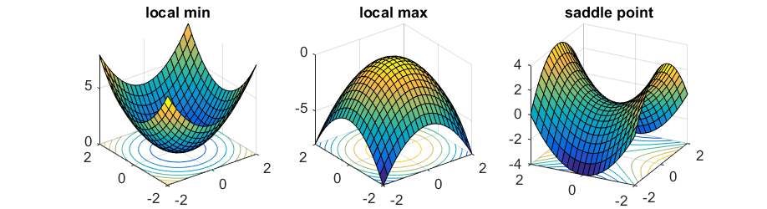

Generative Adversarial Networks

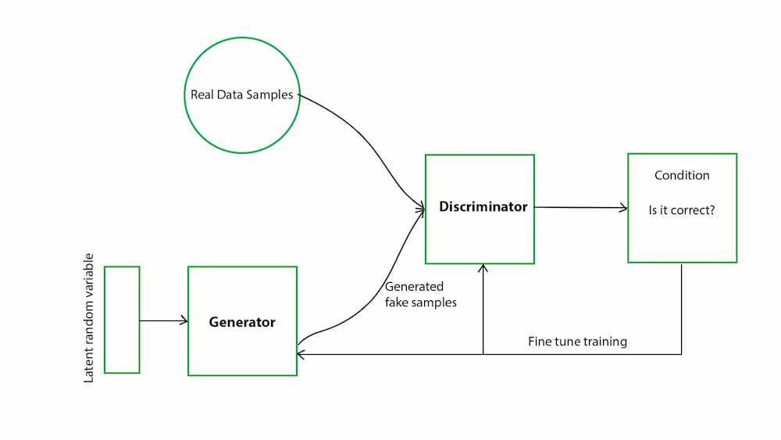

Generative Adversarial Networks (GANs) are a type of deep learning model that consists of two neural networks: the generator and the discriminator. Here's an easy-to-understand explanation of GANs:

1. **Generator**:
   * The generator's role is to create new data samples, such as images, based on random noise or input.
   * It starts with random noise or input data and learns to generate realistic data that resembles the training data.
   * Think of the generator as an artist trying to create paintings similar to famous artworks based on imagination.
2. **Discriminator**:
   * The discriminator's job is to distinguish between real data from the training set and fake data produced by the generator.
   * It learns to classify data as either real (from the training set) or fake (generated by the generator).
   * Imagine the discriminator as an art critic trying to identify genuine paintings from counterfeit ones.
3. **Training Process**:
   * The two networks are trained simultaneously in a competitive manner.
   * The generator aims to produce data that can fool the discriminator into classifying it as real.
   * Meanwhile, the discriminator gets better at distinguishing real data from fake data.
   * This back-and-forth training process improves both networks iteratively.
4. **Key Concepts**:
   * **Adversarial Learning**: GANs use adversarial learning, where the generator and discriminator are adversaries, competing to outsmart each other.
   * **Loss Functions**: GANs use specific loss functions, like binary cross-entropy, to measure the performance of the generator and discriminator.
   * **Mode Collapse**: Sometimes, GANs face challenges like mode collapse, where the generator produces limited variations of data instead of diverse samples.
5. **Applications**:
   * GANs are widely used for generating realistic images, videos, and even text.
   * They have applications in image editing, style transfer, data augmentation, and creating synthetic data for training other models.

In summary, GANs are a powerful class of models that leverage the competition between a generator and discriminator to produce realistic data samples. They have diverse applications in generating creative content and enhancing various tasks in machine learning and artificial intelligence.

Multi-task Deep Learning, Multi-view Deep Learning.

Multi-task Deep Learning and Multi-view Deep Learning in easy-to-understand language:

1. **Multi-task Deep Learning**:
   * **What it does**: Multi-task learning is like a student learning multiple subjects in school simultaneously, where each subject (task) shares some underlying knowledge with others.
   * **How it works**: In deep learning, this means training a single model to perform multiple tasks (like image classification and object detection) instead of separate models for each task.
   * **Benefits**: It can lead to better generalization and performance as the model learns common features across tasks, similar to how learning multiple subjects can improve overall understanding.
   * **Example**: A multi-task deep learning model for healthcare might predict both disease diagnosis and patient prognosis from medical images and records.
2. **Multi-view Deep Learning**:
   * **What it does**: Multi-view learning is like understanding an object from different perspectives, where each view provides unique information.
   * **How it works**: In deep learning, this involves using multiple representations or "views" of the data (such as images from different angles or modalities like text and images) to improve learning.
   * **Benefits**: It helps capture complementary information from diverse sources, enhancing the model's understanding and robustness.
   * **Example**: A multi-view deep learning system for autonomous driving might fuse information from camera images, lidar data, and radar signals to improve object detection and scene understanding.

In essence, multi-task deep learning tackles multiple related tasks simultaneously, leveraging shared knowledge. On the other hand, multi-view deep learning integrates diverse data perspectives to enrich learning and decision-making processes. Both approaches enhance the capabilities and performance of deep learning models across various domains and applications.

**Must read topics and Questions in Deep Learning**

**(Please do not limit yourself up to these topics)**

1. If a neural network uses a sigmoid transfer function, what is the output when the input is 2?

Here's the formula for the sigmoid function:

σ(x) = 1 / (1 + e^(-x))

Where e is the base of the natural logarithm (approximately 2.71828).

If we plug in 2 for x, we get:

σ(2) = 1 / (1 + e^(-2)) ≈ 0.880797

1. Given two classes in a dataset, how can you mathematically determine if they are linearly separable?

• **Define Linear Separability**:

* Two classes are linearly separable if a straight line (in 2D) or hyperplane (in higher dimensions) can separate them without any overlap.

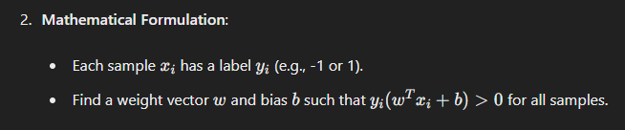• **Use Support Vector Machine (SVM)**:

* Formulate the problem as finding www and bbb that maximize the margin between the two classes.
* SVM tries to find the optimal hyperplane that separates the classes.

• **Check for Linearity**:

* If the SVM classifier can separate the classes perfectly (achieves 100% accuracy), the classes are linearly separable.
* If the SVM cannot achieve perfect separation, the classes are not linearly separable.

1. Create a table listing the mathematical formulas for three different activation functions used in neural networks and describe one advantage for each.

three different activation functions used in neural networks along with a description of one advantage for each:

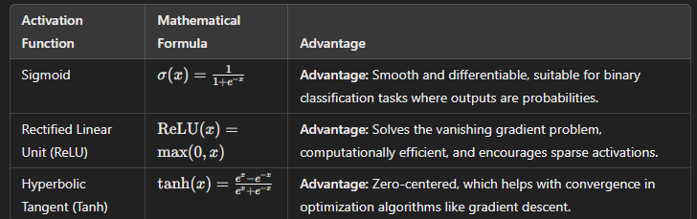

1. By what percentage should a dataset be normalized if the original range is [0, 100] and the desired range is [0, 1]?

To normalize a dataset from an original range of [0, 100] to a desired range of [0, 1], you can use the min-max normalization technique. The formula for min-max normalization is:



In this case:

* Original range: [0, 100]
* Desired range: [0, 1]

The min value is 0 and the max value is 100 in the original range.

Let's calculate the percentage for normalization:

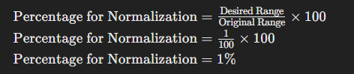So, the dataset should be normalized by 1% to achieve the desired range of [0, 1].

1. How does applying a threshold value of 128 to a grayscale image with pixel values ranging from 0 to 255 segment the image?

Applying a threshold value of 128 to a grayscale image with pixel values ranging from 0 to 255 segments the image into two distinct regions based on pixel intensity. Here's how it works:

1. **Thresholding Process**:
   * For each pixel in the grayscale image, if the pixel value is greater than or equal to the threshold value (128 in this case), it is set to the maximum intensity value (255 for an 8-bit grayscale image).
   * If the pixel value is less than the threshold value, it is set to the minimum intensity value (0 for an 8-bit grayscale image).
2. **Segmentation Effect**:
   * Pixels with intensity values greater than or equal to 128 become white (255) after thresholding.
   * Pixels with intensity values less than 128 become black (0) after thresholding.
3. **Result**:
   * The image is segmented into two regions: areas where the pixel intensity is higher than the threshold appear as white, while areas with pixel intensity lower than the threshold appear as black.

This segmentation technique is commonly used for tasks like creating binary masks, where certain features or regions of interest in an image are separated from the background based on their intensity values.

1. When tuning hyperparameters in a machine learning model, how many combinations would you evaluate if you have 4 hyperparameters, each with 5 possible values?

If you have 4 hyperparameters, each with 5 possible values, you would evaluate 545^454 combinations. This is because for each hyperparameter, there are 5 possible values, and since you have 4 hyperparameters, you multiply 5 by itself 4 times:

Number of Combinations=5^4=625\text{Number of Combinations} = 5^4 = 625Number of Combinations=5^4=625

So, you would evaluate 625 combinations when tuning hyperparameters in your machine learning model.

1. Calculate the difference in error rates if a model is overfitted with an error rate of 2% on training data but 15% on test data, compared to an underfitted model with 10% error on both training and test data.

To calculate the difference in error rates between an overfitted model and an underfitted model, we subtract the test error rate from the training error rate for each case.

1. **Overfitted Model**:
   * Training Error Rate: 2%
   * Test Error Rate: 15%
   * Difference: 15%−2%=13%
2. **Underfitted Model**:
   * Training Error Rate: 10%
   * Test Error Rate: 10%
   * Difference: 10%−10%=0%

So, the difference in error rates between the overfitted model and the underfitted model is 13%.

1. Explain the gradient descent algorithm by calculating the updated weight if the learning rate is 0.01, the current weight is 0.5, and the gradient is 0.1.

Gradient descent is an optimization algorithm commonly used in machine learning to minimize the cost function of a model by adjusting its parameters iteratively. Here's how it works:

1. **Initialization**:
   * Start with an initial weight www (in this case, w=0.5w = 0.5w=0.5).
   * Choose a learning rate α\alphaα (in this case, α=0.01\alpha = 0.01α=0.01), which determines how large each step is during optimization.
2. **Calculate the Gradient**:
   * The gradient ∇J(w)\nabla J(w)∇J(w) represents the direction and magnitude of the steepest ascent of the cost function J(w)J(w)J(w) with respect to the weight www.
   * Given the gradient ∇J(w)=0.1\nabla J(w) = 0.1∇J(w)=0.1, it means the cost function is increasing at a rate of 0.1 when moving in the direction of increasing www.
3. **Update the Weight**:
   * The weight is updated using the formula: w:=w−α×∇J(w)w := w - \alpha \times \nabla J(w)w:=w−α×∇J(w)
   * Substituting the values: w:=0.5−0.01×0.1=0.5−0.001=0.499w := 0.5 - 0.01 \times 0.1 = 0.5 - 0.001 = 0.499w:=0.5−0.01×0.1=0.5−0.001=0.499

So, if the learning rate is 0.01, the current weight is 0.5, and the gradient is 0.1, the updated weight using the gradient descent algorithm would be approximately 0.499.

1. How is the error backpropagated through a network if the output layer error is 0.3 and the hidden layer activation is 0.7?

To backpropagate the error through a neural network, you use the chain rule to calculate the error contributions from each layer. Here's how it works:

1. **Error at Output Layer**:
   * Let's say the error at the output layer is 0.3.
2. **Backpropagation Step**:
   * Start with the error at the output layer.
   * Multiply the output layer error by the derivative of the activation function at the hidden layer.

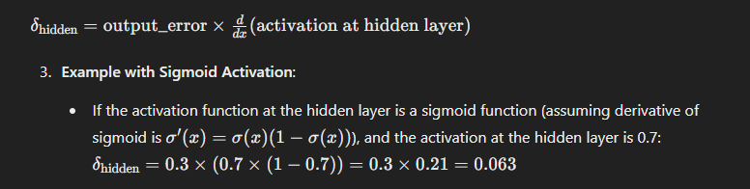So, the error to be backpropagated from the output layer to the hidden layer would be 0.063. This process continues backward through the network, updating the weights based on these error gradients to minimize the overall error in the network during training.

1. What is the primary structural difference between feedforward neural networks and recurrent neural networks, and how does this difference affect their use cases?

difference between feedforward neural networks (FNNs) and recurrent neural networks (RNNs), along with how this difference affects their use cases:

| **Structural Difference** | **Feedforward Neural Networks (FNNs)** | **Recurrent Neural Networks (RNNs)** |
| --- | --- | --- |
| Information Flow | Unidirectional, from input to output without loops or cycles. | Bidirectional with loops/cycles, allowing information retention. |
| Handling Sequential Data | Not designed for sequential data; each input is independent. | Specifically designed for sequential data, processing sequences step by step. |
| Network Architecture | No internal memory or state; each input is processed independently. | Contains internal memory or state, retaining information across steps. |
| Output Dependency | Output at each step depends only on the current input. | Output at each step depends on current input and previous inputs. |
| Use Cases | Image classification, sentiment analysis, regression tasks. | Time series prediction, natural language processing, speech recognition, etc. |

This table highlights how the structural differences between FNNs and RNNs influence their capabilities and suitability for different types of tasks and data, with FNNs excelling in processing independent inputs and RNNs specializing in handling sequential and time-dependent data.

1. Describe the five main steps in the process cycle of machine learning, starting from data collection.

the five main steps in the process cycle of machine learning:

1. **Data Collection**: Gather relevant and representative data from various sources.
2. **Data Preprocessing**: Clean, transform, and split the data into training, validation, and test sets.
3. **Model Selection and Training**: Choose an appropriate machine learning model and train it using the training data.
4. **Model Evaluation**: Evaluate the model's performance using validation data and adjust hyperparameters for optimization.
5. **Model Deployment and Monitoring**: Deploy the trained model into production, monitor its performance, and update as needed to maintain accuracy and reliability.
6. How is speech recognition applied in virtual assistants, and what is the accuracy percentage if the system correctly identifies 180 out of 200 spoken commands?

Speech recognition is a key technology used in virtual assistants like Siri, Alexa, and Google Assistant. Here's how it's applied and how accuracy is calculated:

1. **Application in Virtual Assistants**:
   * Virtual assistants use speech recognition to understand and interpret spoken commands or queries from users.
   * The system converts spoken words into text using speech recognition algorithms.
   * Natural Language Processing (NLP) techniques are then applied to understand the meaning of the text and execute the appropriate actions or responses.
2. **Accuracy Calculation**:
   * To calculate accuracy, divide the number of correctly identified commands by the total number of commands and multiply by 100 to get a percentage.

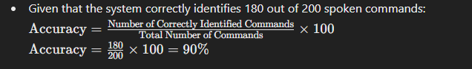So, the accuracy percentage of the system in correctly identifying 180 out of 200 spoken commands is 90%.

1. Define the distinction between learning and training in machine learning, and explain how long each process typically takes for a model with 10,000 parameters.

distinction between learning and training in machine learning, along with the typical duration for training a model with 10,000 parameters:

| **Aspect** | **Learning** | **Training** |
| --- | --- | --- |
| Definition | Process of acquiring knowledge or improving performance | Process of teaching a model on data to learn patterns and relationships |
| Techniques | Includes supervised, unsupervised, reinforcement learning, etc. | Involves adjusting model parameters based on input data and labels/patterns |
| Duration | Varies based on the learning task and model complexity | Varies based on model complexity, dataset size, hardware, and optimization methods |

Points of Distinction:

1. **Learning**:
   * Refers to the broader process of acquiring knowledge or improving performance in machine learning.
   * Involves various techniques such as supervised learning (with labeled data), unsupervised learning (finding patterns in unlabeled data), reinforcement learning (learning through trial and error), etc.
2. **Training**:
   * Specific to teaching a model on a dataset to learn patterns and relationships in the data.
   * Involves adjusting the model's internal parameters based on input data and corresponding labels (in supervised learning) or patterns (in unsupervised learning) to minimize a predefined loss or error function.

Duration of Training:

* The time taken for training a model with 10,000 parameters can vary significantly based on factors such as model complexity, dataset size, available computational resources, and optimization algorithms.
* Typically, training a model with 10,000 parameters on a moderately sized dataset using modern hardware can take from several minutes to several hours. However, complex models or large datasets may require days or weeks for training.

This distinction helps understand the different phases in the machine learning process and the time considerations involved in training machine learning models of varying complexities.

1. How does forward propagation work in artificial neural networks, and calculate the output if the input is 1, the weight is 2, and the activation function is ReLU?

Forward propagation is the process by which inputs are passed through the neural network's layers to compute the final output. Here's how it works:

1. **Input Layer**:
   * The input value(s) are fed into the first layer of the neural network, known as the input layer.
   * Each input is multiplied by its corresponding weight, and the results are summed.
2. **Activation Function**:
   * The summed value is then passed through an activation function.
   * In this case, the activation function is ReLU (Rectified Linear Unit).
3. **Output Calculation**:
   * If the result of the activation function is positive, it is kept as is.
   * If the result is negative, it is set to zero (ReLU function).
   * The final output is the result of the activation function applied to the weighted sum of inputs.

Let's calculate the output with the given values:

* Input: 1
* Weight: 2
* Activation Function: ReLU (max(0, x))

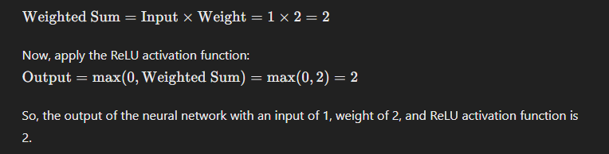

1. If a neural network’s cost function is given by J(θ)=12m∑i=1m(hθ(x(i))−y(i))2J(\theta) = \frac{1}{2m} \sum_{i=1}^{m} (h_\theta(x^{(i)}) - y^{(i)})^2J(θ)=2m1​∑i=1m​(hθ​(x(i))−y(i))2, how does this relate to the gradient descent update rule for a weight θ\thetaθ?

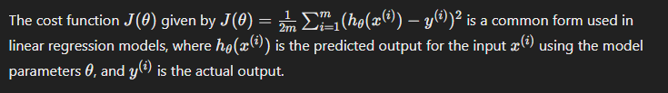 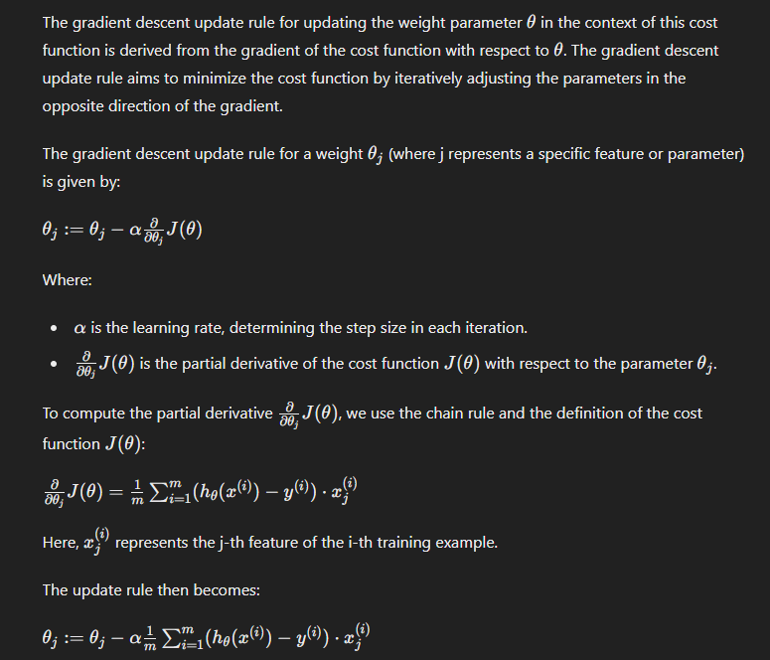

1. Identify one common challenge associated with artificial neural networks and illustrate it with a diagram.

One common challenge associated with artificial neural networks is the issue of vanishing gradients or exploding gradients during training. This problem occurs when the gradients of the cost function with respect to the network parameters become very small (vanishing gradients) or very large (exploding gradients), making it difficult for the network to learn effectively.

The vanishing gradients problem occurs when gradients become very small as they propagate backward through multiple layers, especially in deep neural networks with many layers. This can lead to slower convergence or even stagnation in training, as the network struggles to update the parameters effectively based on the small gradients.

To address this challenge, techniques such as careful weight initialization, using activation functions that mitigate vanishing gradients (e.g., ReLU), batch normalization, and employing gradient clipping can be helpful

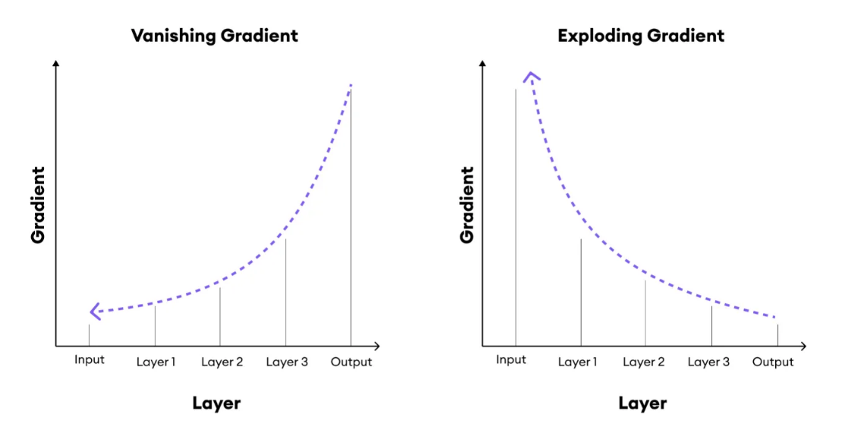

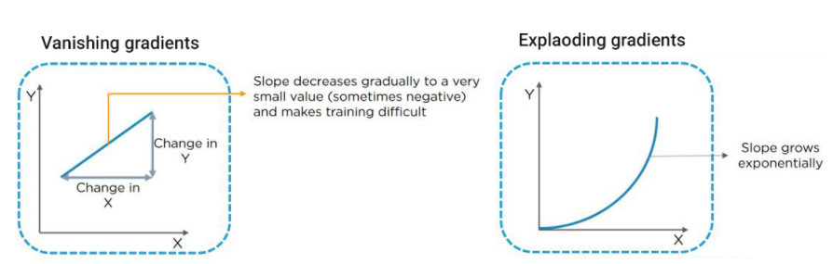

1. What is the significance of the perceptron in the perceptron model, and how many iterations does it take to converge if the learning rate is 0.1 and the error decreases by 0.01 per iteration?

The significance of the perceptron in the perceptron model lies in its role as the fundamental building block of artificial neural networks. The perceptron is a simple linear binary classifier that takes multiple inputs, applies weights to these inputs, sums them up, and passes the result through an activation function (typically a step function) to produce an output. It's a basic unit that forms the basis of more complex neural network architectures.

Regarding the convergence of the perceptron model, the number of iterations required for convergence depends on various factors such as the complexity of the problem, the separability of the data, and the learning rate.

Given that the error decreases by 0.01 per iteration and the learning rate is 0.1, we can use this information to estimate the convergence. The learning rate determines the size of the step taken towards minimizing the error in each iteration. If the error decreases by 0.01 per iteration, and the learning rate is 0.1, it means that the error decreases by 10% of its current value in each iteration.

Let's denote the initial error as E0 and the error after k iterations as Ek. We have:

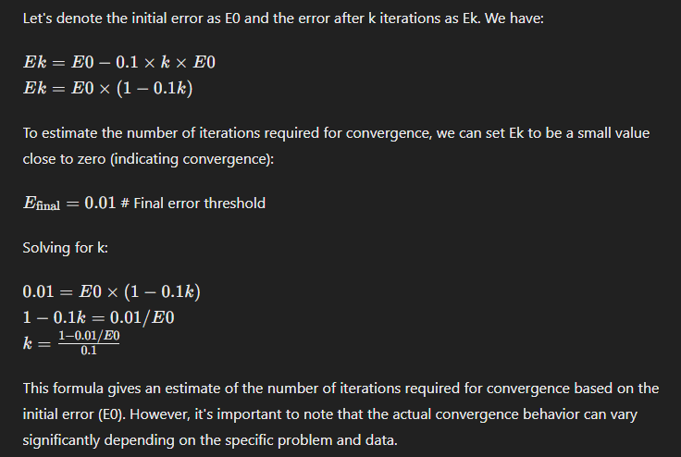

1. Explain how linear and non-linear activation functions are utilized in neural networks, and provide an example where a non-linear activation function outperforms a linear one.

Linear and non-linear activation functions play crucial roles in neural networks by introducing complexity and flexibility into the model's decision-making process.

1. **Linear Activation Function**:
   * The linear activation function is simple and takes the form of f(x)=xf(x) = xf(x)=x, where the output is directly proportional to the input.
   * It's commonly used in linear regression models or when the output is expected to be a linear combination of the inputs.
   * However, in deep neural networks, stacking multiple layers with linear activation functions results in the overall function remaining linear. This limitation hinders the network's ability to learn complex, non-linear relationships in the data.
2. **Non-linear Activation Function**:
   * Non-linear activation functions introduce non-linearity into the network, allowing it to learn and represent complex patterns and relationships in the data.
3. 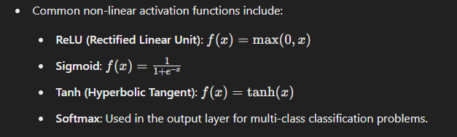**Example of Non-linear Outperforming Linear**:
   * Consider a scenario where the task is to classify images of handwritten digits (0-9) using a neural network.
   * Using a linear activation function in the hidden layers restricts the network's ability to learn the non-linear features that distinguish between different digits.
   * On the other hand, using a non-linear activation function like ReLU or sigmoid allows the network to capture complex patterns in the images, improving classification accuracy.
   * For instance, ReLU is particularly effective in image classification tasks as it introduces non-linearity and helps the network learn hierarchical representations of features.

In this example, the non-linear activation function (e.g., ReLU) outperforms the linear activation function by enabling the neural network to learn and represent non-linear relationships in the data, leading to improved performance in complex tasks like image classification.

1. Calculate the total reward in a reinforcement learning scenario where the agent receives rewards of 1, 0, 3, and 5 over four actions.

To calculate the total reward in a reinforcement learning scenario where the agent receives rewards of 1, 0, 3, and 5 over four actions, you simply sum up all the rewards.

Total Reward = 1 + 0 + 3 + 5 = 9

So, the total reward accumulated by the agent after these four actions is 9.

1. Describe the concept of Long Short-Term Memory (LSTM) in recurrent neural networks, and explain how it helps prevent the vanishing gradient problem over 50 time steps.

Long Short-Term Memory (LSTM) is a type of recurrent neural network (RNN) architecture designed to address the vanishing gradient problem and capture long-term dependencies in sequential data. Here's how LSTM works and why it is effective over long sequences like 50 time steps:

1. **Concept of LSTM**:
   * LSTM networks consist of memory cells that can maintain information over time steps, allowing them to capture long-term dependencies in sequential data.
   * The key components of an LSTM cell include:
     + **Cell State (Ct)**: Represents the long-term memory information that the cell retains and updates over time.
     + **Input Gate (i)**: Controls how much new information is added to the cell state.
     + **Forget Gate (f)**: Controls how much old information is removed from the cell state.
     + **Output Gate (o)**: Determines how much of the cell state is used to compute the output.
2. **Preventing Vanishing Gradient Problem**:
   * The LSTM architecture includes mechanisms such as the forget gate, which allows the network to selectively retain or forget information based on the context of the input sequence.
   * During backpropagation through time (BPTT), the gradients flowing through the LSTM cells are less likely to vanish or explode compared to traditional RNNs. This is because the forget gate and other gating mechanisms control the flow of gradients, preventing them from becoming too small or too large.
   * The cell state in LSTM acts as a conveyor belt where information can flow across multiple time steps without being significantly altered, helping to maintain gradients and learn long-term dependencies effectively.
3. **Effectiveness over 50 Time Steps**:
   * Over 50 time steps, traditional RNNs often struggle with the vanishing gradient problem, where gradients become extremely small or zero, hindering learning.
   * LSTM's design with gated mechanisms and a memory cell allows it to retain relevant information and update the cell state selectively, making it more robust over long sequences.
   * The forget gate plays a crucial role in discarding irrelevant information from the past, ensuring that the network focuses on relevant long-term dependencies without being overwhelmed by noise or irrelevant context.

In summary, LSTM in recurrent neural networks addresses the vanishing gradient problem by incorporating gating mechanisms and a memory cell, enabling it to capture long-term dependencies effectively over 50 or more time steps without suffering from significant degradation in learning performance.

1. How is the sigmoid function utilized in the perceptron model, and what is the output if the input is -1?

In the perceptron model, the sigmoid function (also known as the logistic function) is often used as the activation function in the output layer. The sigmoid function is given by:

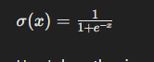

Here's how the sigmoid function is utilized in the perceptron model:

1. **Binary Classification**:
   * In binary classification tasks, the perceptron model predicts a binary output (e.g., 0 or 1).
   * The output of the perceptron, before applying the sigmoid function, is a linear combination of the input features and weights, potentially ranging from negative to positive values.
   * The sigmoid function is then applied to this linear combination to squash the output into the range [0, 1], interpreting the result as a probability.
2. **Output Interpretation**:
   * The output of the sigmoid function can be interpreted as the probability that the input belongs to the positive class (class 1) in binary classification.
   * If the sigmoid output is close to 1, it indicates high confidence that the input belongs to the positive class.
   * If the sigmoid output is close to 0, it indicates high confidence that the input belongs to the negative class.

Now, let's calculate the output of the sigmoid function when the input is -1:

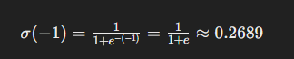

So, the output of the sigmoid function when the input is -1 is approximately 0.2689, which represents the probability that the input belongs to the positive class in a binary classification scenario.

1. Design an architectural model for image classification using artificial neural networks, and describe the number of layers and neurons typically used.

**Input Layer**:

The input layer receives the raw image data. Each neuron in this layer represents a pixel or a feature of the image.

The size of this layer depends on the dimensions of the input images. For example, if the input images are 100x100 pixels, the input layer would have 10,000 neurons (100 * 100).

**Hidden Layers**:

The hidden layers are responsible for learning hierarchical features from the input images.

Typically, convolutional layers are used in CNNs for image classification tasks. These layers consist of multiple filters (neurons) that slide across the input image, extracting features such as edges, textures, and patterns.

Pooling layers (e.g., max pooling) are often used after convolutional layers to reduce spatial dimensions and retain important features.

The number of hidden layers and neurons in each layer can vary based on the complexity of the classification task and the size of the input images. A common configuration includes several convolutional layers followed by pooling layers, with increasing numbers of filters/neurons in deeper layers to capture more abstract features.

**Flattening Layer**:

After the convolutional and pooling layers, a flattening layer is used to convert the 2D feature maps into a 1D vector. This prepares the data for feeding into the fully connected layers.

The number of neurons in the flattening layer is equal to the total number of features extracted by the convolutional layers.

**Fully Connected Layers**:

Fully connected (dense) layers are added after the flattening layer to perform classification based on the extracted features.

The number of neurons in these layers can vary based on the complexity of the classification task and the number of classes to be predicted.

The final fully connected layer typically has neurons equal to the number of classes, followed by a softmax activation function to output class probabilities.

**Output Layer**:

The output layer produces the final classification results.

For image classification with multiple classes, the output layer uses a softmax activation function to compute class probabilities, and the class with the highest probability is predicted as the output.

Overall, a typical architecture for image classification using artificial neural networks includes convolutional layers for feature extraction, pooling layers for spatial reduction, fully connected layers for classification, and an output layer for final predictions. The exact number of layers and neurons depends on factors such as input image size, complexity of the task, and desired model performance.

1. How does the convergence theorem apply to the perceptron model, and what does it imply if a perceptron cannot find a solution after 1000 iterations?

The convergence theorem is a fundamental concept in machine learning, including the perceptron model. In the context of the perceptron model, the convergence theorem states that if the training data is linearly separable, the perceptron learning algorithm will converge and find a solution (i.e., a decision boundary) that separates the classes.

Here's how the convergence theorem applies to the perceptron model:

1. **Linear Separability**:
   * If the classes in the training data can be perfectly separated by a hyperplane (linearly separable), the perceptron algorithm will converge and find a weight vector that correctly classifies all training examples.
2. **Convergence**:
   * The perceptron learning algorithm iteratively adjusts the weights based on misclassified examples until all examples are correctly classified or a maximum number of iterations is reached.
   * During each iteration, the algorithm updates the weights to reduce misclassifications, gradually improving the separation between classes.
3. **Implications of Non-Convergence**:
   * If a perceptron cannot find a solution after a specified number of iterations (e.g., 1000 iterations), it implies that the training data may not be linearly separable.
   * Non-convergence after a large number of iterations suggests that the perceptron algorithm cannot find a hyperplane that perfectly separates the classes, even with further weight adjustments.
   * In such cases, alternative approaches or more complex models (e.g., multi-layer perceptron, support vector machines with non-linear kernels) may be necessary to handle non-linearly separable data.

It's important to note that the convergence theorem applies specifically to linearly separable data in the context of the perceptron model. For non-linearly separable data, the perceptron algorithm may not converge, and other algorithms or models capable of handling non-linearities are required.

1. Identify three common issues in machine learning and suggest one method to address each issue.

three common issues in machine learning along with suggested methods to address each issue:

1. **Overfitting**:
   * **Issue**: Overfitting occurs when a machine learning model learns the training data too well, capturing noise and irrelevant patterns that do not generalize to new, unseen data.
   * **Solution**: One method to address overfitting is regularization. Regularization techniques add a penalty term to the model's objective function, discouraging overly complex models that fit the training data too closely. For example, L2 regularization (Ridge regression) adds a penalty based on the squared magnitude of the model's weights, promoting smaller coefficients and reducing overfitting.
2. **Underfitting**:
   * **Issue**: Underfitting occurs when a machine learning model is too simple to capture the underlying patterns in the training data, resulting in poor performance on both training and test data.
   * **Solution**: To address underfitting, increasing model complexity can be beneficial. This can be achieved by using more sophisticated algorithms (e.g., switching from linear regression to polynomial regression) or adding more features to the model to capture additional information from the data. Additionally, fine-tuning hyperparameters (e.g., increasing the number of layers in a neural network) can help improve model complexity.
3. **Data Imbalance**:
   * **Issue**: Data imbalance occurs when one class in a classification problem is significantly more prevalent than the others, leading to biased models that perform well on the majority class but poorly on minority classes.
   * **Solution**: One method to address data imbalance is through resampling techniques. This includes oversampling the minority class (e.g., using techniques like Synthetic Minority Over-sampling Technique - SMOTE) to create synthetic examples or undersampling the majority class to balance the class distribution. Another approach is using class weights during training, where the loss function penalizes errors in the minority class more heavily, helping the model prioritize learning from these instances.

These methods are commonly used to mitigate issues such as overfitting, underfitting, and data imbalance in machine learning models, promoting better generalization and performance on unseen data.

1. Describe the working cycle of a single-layer perceptron model from input to output.

**Input Data**:

The model starts with input data represented as a feature vector [x1, x2, ..., xn].

**Weighted Sum**:

The input features are multiplied by their corresponding weights and summed to produce the net input (z = w1 * x1 + w2 * x2 + ... + wn * xn).

**Activation Function**:

The net input is passed through an activation function, producing the output of the perceptron.

Common activation functions include step functions or sigmoid functions.

**Output**:

The output of the activation function is the predicted output of the perceptron, often interpreted as a class label (e.g., 1 or 0) in binary classification.

**Training**:

During training, the model adjusts its weights based on the error between predicted and actual outputs.

The perceptron learning rule or gradient descent can be used for weight updates to minimize errors.

**Testing/Prediction**:

After training, the model can make predictions on new data by applying learned weights to input features.

The output of the perceptron predicts the class label or value for the new instance.

Overall, the single-layer perceptron model learns from input data through weight adjustments during training, allowing it to predict outputs for new data based on learned patterns.

1. What are some weight initialization techniques used in deep neural networks, and how do they impact the first few iterations of training?

Weight initialization techniques play a crucial role in training deep neural networks by providing a good starting point for the optimization process. Here are some commonly used weight initialization techniques and their impact on the first few iterations of training:

1. **Zero Initialization**:
   * In this technique, all weights are initialized to zero.
   * Impact: Zero initialization is generally avoided in deep neural networks because it leads to symmetry breaking issues. All neurons in a layer would compute the same output, and gradients would be the same during backpropagation, hindering learning.
2. **Random Initialization**:
   * Weights are randomly initialized using a uniform or normal distribution.
   * Impact: Random initialization helps break symmetry and introduces diversity in neuron activations, enabling the network to learn different features. However, it may lead to exploding or vanishing gradients, especially in deep networks with many layers.
3. **Xavier/Glorot Initialization**:
   * Weights are initialized from a normal distribution with zero mean and variance scaled based on the number of input and output units.
   * Impact: Xavier/Glorot initialization addresses the exploding/vanishing gradient problem by keeping the variance of activations and gradients relatively stable across layers. This technique is effective for shallow and moderately deep networks.
4. **He Initialization**:
   * Weights are initialized from a normal distribution with zero mean and variance scaled based on the number of input units.
   * Impact: He initialization is similar to Xavier/Glorot initialization but more suitable for deep networks. It prevents gradients from vanishing or exploding and helps in faster convergence during training.
5. **LeCun Initialization**:
   * Introduced by Yann LeCun, this initialization method uses a normal distribution with zero mean and variance scaled based on the number of input units.
   * Impact: LeCun initialization is specifically designed for networks with sigmoid or hyperbolic tangent activation functions. It can improve convergence and learning speed in such networks.

The impact of weight initialization techniques on the first few iterations of training is significant. Poor initialization can lead to slow convergence, vanishing/exploding gradients, and suboptimal performance. On the other hand, well-chosen initialization methods help in stabilizing training, reducing the risk of gradient-related issues, and facilitating effective learning in deep neural networks.

1. What are the limitations of a single-layer perceptron, and how does the introduction of a multilayer perceptron overcome these limitations?

The single-layer perceptron has several limitations that are overcome by the introduction of a multilayer perceptron (MLP):

1. **Linear Separability**:
   * Limitation of Single-Layer Perceptron: The single-layer perceptron can only classify linearly separable data. It cannot learn non-linear decision boundaries.
   * Overcoming with MLP: The introduction of hidden layers in an MLP allows it to learn non-linear decision boundaries. By stacking multiple layers with non-linear activation functions, an MLP can model complex relationships in the data.
2. **XOR Problem**:
   * Limitation of Single-Layer Perceptron: The single-layer perceptron fails to solve the XOR problem, where the classes are not linearly separable.
   * Overcoming with MLP: An MLP with at least one hidden layer and non-linear activation functions (e.g., sigmoid, ReLU) can successfully solve the XOR problem by learning a hierarchical representation of the input data.
3. **Limited Representation Power**:
   * Limitation of Single-Layer Perceptron: Single-layer perceptrons have limited representation power due to their linear nature. They can only model linear relationships between input and output.
   * Overcoming with MLP: MLPs can capture complex patterns and features in the data by incorporating multiple hidden layers. Each hidden layer learns increasingly abstract features, allowing the network to represent intricate relationships.
4. **Feature Learning**:
   * Limitation of Single-Layer Perceptron: Single-layer perceptrons rely solely on the input features without the ability to learn hierarchical representations or abstract features.
   * Overcoming with MLP: MLPs excel at feature learning by leveraging multiple layers with non-linear activation functions. This hierarchical feature learning enables the network to extract relevant features automatically from raw input data.
5. **Non-linear Mapping**:
   * Limitation of Single-Layer Perceptron: Single-layer perceptrons can only perform linear mapping from input to output.
   * Overcoming with MLP: MLPs can learn complex non-linear mappings between input and output through the interactions of multiple layers and non-linear activation functions. This enables them to model diverse and intricate relationships in the data.

In summary, the introduction of a multilayer perceptron overcomes the limitations of a single-layer perceptron by enabling non-linear modeling, hierarchical feature learning, enhanced representation power, and the ability to solve problems that require non-linear decision boundaries.

1. Compare the advantages and disadvantages of using artificial neural networks for time series forecasting versus traditional statistical methods.

comparison of the advantages and disadvantages of using artificial neural networks (ANNs) versus traditional statistical methods for time series forecasting:

| **Criteria** | **Artificial Neural Networks (ANNs)** | **Traditional Statistical Methods** |
| --- | --- | --- |
| **Advantages** |  |  |
| Non-linearity | Captures non-linear patterns effectively. | Limited ability to model non-linear patterns. |
| Feature Learning | Automatically learns relevant features from data. | May require manual feature engineering. |
| Adaptability | Adapts to changing patterns in data. | Less adaptive without manual adjustments. |
| Handling Complex Data | Can handle large volumes of complex data. | Limited scalability with complex datasets. |
| **Disadvantages** |  |  |
| Complexity and Interpretability | Complex models with reduced interpretability. | Transparent and interpretable models. |
| Data Requirements | May require large amounts of training data. | Can perform well with limited historical data. |
| Training Time | Computationally intensive and time-consuming. | More computationally efficient and faster. |
| Limited Non-linearity | Models non-linear relationships effectively. | Limited ability to capture non-linear trends. |
| Manual Feature Engineering | Automatic feature extraction reduces manual effort. | Often requires manual feature selection. |
| Handling Complexity | Can handle high-dimensional and interconnected data. | May struggle with complex, dynamic relationships. |

1. How can the learning rate in gradient descent be simplified, and what effect does a learning rate of 0.01 versus 0.1 have on the convergence speed?

The learning rate in gradient descent determines the size of the steps taken towards minimizing the loss function during training. Simplifying the learning rate involves understanding its impact on convergence speed and model performance.

1. **Simplifying Learning Rate**:
   * The learning rate can be simplified as a hyperparameter that controls the step size during gradient descent optimization.
   * A higher learning rate leads to larger steps, potentially overshooting the minimum and causing oscillations or divergence.
   * A lower learning rate results in smaller steps, increasing the number of iterations required for convergence but offering more stability.
2. **Effect of Learning Rate on Convergence Speed**:
   * **Learning Rate of 0.01**:
     + **Effect**: A low learning rate like 0.01 takes smaller steps, which can lead to slower convergence but may be more stable and less likely to overshoot the minimum.
     + **Impact**: Convergence may require more iterations, but the training process may be smoother and less prone to oscillations.
   * **Learning Rate of 0.1**:
     + **Effect**: A higher learning rate like 0.1 takes larger steps, potentially converging faster but risking overshooting the minimum and oscillations.
     + **Impact**: Convergence speed may be faster initially, but the risk of instability and oscillations increases, requiring careful tuning.

Choosing the appropriate learning rate involves balancing convergence speed with stability. Too high a learning rate can lead to erratic behavior, while too low a learning rate may slow down convergence significantly. Techniques like learning rate scheduling or adaptive learning rate methods (e.g., Adam optimizer) can help adjust the learning rate dynamically during training, optimizing both convergence speed and stability.

1. Critique the use of the ReLU activation function in different scenarios, and explain why it might fail when used in a deep network with all negative inputs.

The Rectified Linear Unit (ReLU) activation function is widely used in neural networks due to its simplicity, computational efficiency, and ability to address the vanishing gradient problem. However, there are scenarios where ReLU may not perform optimally, and understanding these limitations is crucial for effective model design. Here's a critique of using the ReLU activation function in different scenarios and why it might fail in a deep network with all negative inputs:

1. **Advantages of ReLU**:
   * **Simplicity**: ReLU is simple to compute (max(0, x)) and leads to faster training compared to complex activation functions like sigmoid or tanh.
   * **Sparsity**: ReLU induces sparsity in activations by setting negative values to zero, which can help in reducing overfitting and improving generalization.
   * **Avoids Vanishing Gradient**: ReLU helps mitigate the vanishing gradient problem by allowing gradient flow for positive inputs, enabling training of deep networks more effectively.
2. **Limitations and Failure Scenarios**:
   * **Dead Neurons**: In scenarios where all inputs to a ReLU neuron are negative (e.g., during the initial stages of training or for specific data distributions), the neuron becomes inactive (outputting zero), leading to "dead neurons." Dead neurons do not contribute to learning and can hinder the network's capacity to capture information.
   * **Lack of Negative Output Handling**: ReLU does not handle negative inputs well, as it simply sets them to zero. This lack of negative output handling may limit the model's ability to represent negative relationships or information in the data.
   * **Gradient Issues**: ReLU can suffer from gradient issues during training, especially in deep networks. If a large portion of neurons become inactive (output zero), it can lead to the "dying ReLU" problem, where gradients for such neurons remain zero, hindering learning in subsequent layers.
3. **Alternatives and Solutions**:
   * **Leaky ReLU**: Leaky ReLU addresses the issue of dead neurons by allowing a small, non-zero gradient for negative inputs, ensuring some information flow even for negative values.
   * **Parametric ReLU (PReLU)**: PReLU introduces learnable parameters to Leaky ReLU, enabling the network to adaptively determine the slope for negative inputs.
   * **Exponential Linear Units (ELU)**: ELU is another alternative that handles negative inputs gracefully by allowing negative values while maintaining smoothness and avoiding the dying ReLU problem.

In conclusion, while ReLU offers several advantages and is widely used, it has limitations such as dead neurons and gradient issues, especially in scenarios with all negative inputs. Choosing the right activation function or its variants based on the specific characteristics of the data and network architecture is essential for overcoming these limitations and achieving optimal performance.